694TAS

USER'S MANUAL
M/B For Socket 370 Pentium® III Processor

NO. G03-694TAS2A

Release date: August 2001

** Year 2000 compliant **

Trademark:
- Pentium is registered trademark and Celeron is a trademark of Intel corporation,
the other names and brands are the property of their respective owners.
- Specifications and Information contained in this documentation are furnished for information use only, and are
subject to change at any time without notice, and should not be construed as a commitment by manufacturer.

TABLE OF CONTENT

USER’S NOTICE 1
MANUAL REVISION INFORMATION 2
COOLING SOLUTIONS 2
CHAPTER 1 INTRODUCTION OF 694TAS MOTHERBOARD
1-1 FEATURE OF MOTHERBOARD 3
1-2 SPECIFICATION 4
1-3 PERFORMANCE LIST 5
1-4 LAYOUT & JUMPER SETTING 6
CHAPTER 2 HARDWARE INSTALLATION
2-1 HARDWARE INSTALLATION STEPS 8
2-2 CHECKING MOTHERBAORD'S JUMPER SETTING 8
2-3 INSTALL CPU 10
2-3-1 GLOSSARY 10
2-3-2 INSTALL CPU 11
2-3-3 OVER CLOCK RUNNING 11
2-4 INSTALL MEMORY 12
2-5 EXPANSION CARD 13
2-5-1 PROCEDURE FOR EXPANSION CARD INSTALLATION 13
2-5-2 ASSIGNING IRQ FOR EXPANSION CARD 14
2-5-3 INTERRUPT REQUEST TABLE FOR THIS MOTHERBOARD 14
2-5-4 AGP SLOT 15
2-6 CONNECTORS, HEADERS 15
2-6-1 CONNECTORS 15
2-6-2 HEADERS 18
2-7 STARTING UP YOUR COMPUTER 21
CHAPTER 3 INTRODUCING BIOS
3-1 ENTERING SETUP 22
3-2 GETTING HELP 22
3-3 THE MAIN MENU 23
3-4 STANDARD CMOS FEATURES 25
3-5 ADVANCED BIOS FEATURES 26
3-6 ADVANCED CHIPSET FEATURES 28
3-6-1 DRAM TIMING SETTINGS 29
3-6-2 AGP FUNCTION SETTINGS 30
3-7 INTEGRATED PERIPHERALS 31
3-7-1 ONCHIP IDE FUNCTION 31
3-7-2 ONCHIP SIO FUNCTION 32
3-7-3 ONCHIP DEVICE FUNCTION 34
3-7-3.1 ONCHIP SOUND FUNCTION 34

3-8 POWER MANAGEMENT SETUP 35
3-8-1 POWER MANAGEMENT 36
3-8-2 WAKE UP EVENTS 37
3-8-2.1 IRQS ACTIVITY 38
3-9 PNP/PCI CONFIGURATION SETUP 38
3-10 PC HEALTH STATUS 39
3-11 MISCELLANEOUS CONTROL 40
3-12 LOAD STANDARD/OPTIMIZED DEFAULTS 41
3-13 SET SUPERVISOR/USER PASSWORD 41
CHAPTER 4 DRIVER & FREE PROGRAM INSTALLATION
MAGIC INSTALL SUPPORTS WINDOWS 95/98/98SE/NT4.0/2000 42
4-1 IDE INSTALL VIA SERVICE PACK 4 IN 1 DRIVER 43
4-2 PC-HEALTH INSTALL VIA HARDWARE MONITOR DRIVER 45
4-2-1 HOW TO USE VIA HARDWARE MONITOR APPLICATION
SOFTWARE 45
4-3 SOUND VIA AC97 AUDIO CODEC INSTALLING DRIVER 46
4-4 PC-CILLIN INSTALL PC-CILLIN98 ANTI-VIRUS PROGRAM 47
4-5 HOW TO DISABLE ON-BOARD SOUND 48
4-6 HOW TO UPDATE BIOS 48

ii

USER’S NOTICE

COPYRIGHT OF THIS MANUAL BELONGS TO THE MANUFACTURER. NO PART OF THIS MANUAL, INCLUDING THE PRODUCTS AND SOFTWARE DESCRIBED IN IT MAY BE REPRODUCED, TRANSMITTED OR TRANSLATED INTO ANY LANGUAGE IN ANY FORM OR BY ANY MEANS WITHOUT WRITTEN PERMISSION OF THE MANUFACTURER.

THIS MANUAL CONTAINS ALL INFORMATION REQUIRED TO USE 694TAS MOTHER-BOARD AND WE DO ASSURE THIS MANUAL MEETS USER’S REQUIREMENT BUT WILL CHANGE, CORRECT ANY TIME WITHOUT NOTICE. MANUFACTURER PROVIDES THIS MANUAL “AS IS” WITHOUT WARRANTY OF ANY KIND, AND WILL NOT BE LIABLE FOR ANY INDIRECT, SPECIAL, INCIDENTIAL OR CONSEQUENTIAL DAMAGES (INCLUDING DAMANGES FOR LOSS OF PROFIT, LOSS OF BUSINESS, LOSS OF USE OF DATA, INTERRUPTION OF BUSINESS AND THE LIKE).

PRODUCTS AND CORPORATE NAMES APPEARING IN THIS MANUAL MAY OR MAY NOT BE REGISTERED TRADEMARKS OR COPYRIGHTS OF THEIR RESPECTIVE COMPANIES, AND THEY ARE USED ONLY FOR IDENTIFICATION OR EXPLANATION AND TO THE OWNER’S BENEFIT, WITHOUT INTENT TO INFRINGE.

Manual Revision Information

Reversion Revision History Date
2.0 Second Edition August 2001

Item Checklist
- 694TAS
- Cable for IDE/Floppy
- CD for motherboard utilities
□ Cable for USB Port 3/4 (Option)
- 694TAS User’s Manual

Intel® Processor Family
Thermal Solutions
As processor technology pushes to faster speeds and higher performance, thermal management becomes increasingly crucial when building computer systems. Maintaining the proper thermal environment is key to reliable, long-term system operation. The overall goal in providing the proper thermal environment is keeping the processor below its specified maximum case temperature. Heatsinks induce improved processor heat dissipation through increased surface area and concentrated airflow from attached fans. In addition, interface materials allow effective transfers of heat from the processor to the heatsink. For optimum heat transfer, Intel recommends the use of thermal grease and mounting clips to attach the heatsink to the processor.
When selecting a thermal solution for your system, please refer to the website below for collection of heatsinks evaluated and recommended by Intel for use with Intel processors.
Vendor list for heatsink and fan of Pentium® !!! processor, please visit： http://developer.intel.com/design/Pentiumiii/components/index.htm
Vendor list for heatsink and fan of Intel®Celeron™ processor, please visit： http://developer.intel.com/design/celeron/components/index.htm

Chapter 1
Introduction of 694TAS Motherboard

1-1 Feature of motherboard

The 694TAS motherboard is design for use Intel PentiumIII /Celeron/Tualatin FC-PGA CPU, which utilize the Socket 370 design and the memory size expandable to 1.5GB.

This motherboard use the newest VIA Apollo Pro VT82C694T chipset, whose 133MHz front side bus & 133MHz memory interface delivers a clear upgrade path to the future generation of 133MHz processors and PC-133 SDRAM. The 694TAS motherboard offers ULTRA ATA 100 to provide speedier HDD throughout that boosts overall system performance. Its on board integrated AC’97 2.1 CODEC which is fully compatible with Sound Blaster Pro® that gives you the best sound quality and compatibility.

The special function of Auto Setting and Jump-less solution, allows user to install CPU without change any jumper. User can also setting Front Side Bus Frequency (CPU Host Clock), CPU ratio in BIOS SETUP “Miscellaneous Control” for over-clocking possibility.

With 2 USB control as well as capability of expanding to 4 USB connectors, the 694TAS meet future USB demand also this motherboard includes built-in hardware monitor function that capable of monitor and protect your computer.

The 694TAS motherboard supports ACPI function such like Ring_In Wake Up, Ring_In Power On, Wake On LAN, Wake On Modem, RTC Power On for OS Directed Power Management.

The Special fuction in BIOS SETUP can choose system’s clock step by step between 66∼99Mhz, 100∼132Mhz, 133∼166Mhz to approach Over-Clock possiblilty. This board also provides system auto detection and rebooting function that uses default frequency when system boot fail by over-clocking.

This motherboard supports standard Synchronous DRAM (SDRAM) and Virtual Channel Memory SDRAM (VCM SDRAM), in a flexible mix/match manner.

This motherboard provides high performance & meets future specification demand. It is really wise choice for your computer.

1-2 Specification

Spec | Description
Design | - ATX form factor 4 layers PCB size: 30.5x19.0cm
Chipset | - VIA Apollo Pro VT82C694T/82C686B Chipset
Socket 370 | - Support Intel Pentium III /Celeron/Tualatin FC-PGA CPU  - Support Front Side Bus 66Mhz/100Mhz/133Mhz CPU
Memory Socket | - 168-pin DIMM socket x 3  - PC-100/PC-133 SDRAM/Virtual Channel Memory SDRAM (VCM SDRAM)  - Expandable to 1.5GB  - Support 3.3V SDRAM DIMM
Expansion Slot & Headers | - AGP slot x1  - 32-bit PCI slot x 5  - AMR slot x 1  - ISA slot x 1
Integrate IDE | - 2 channel of Bus Master IDE port supporting ULTRA DMA 33/66/100 mode devices
Audio | - AC’97 Digital Audio controller integrated  - AC’97 Audio CODEC on board  - Audio driver and utility included
PC Health | - Monitoring CPU/System Temperature, FAN Speed, System Voltage
BIOS | - Award 2Mb Flash ROM
Multi I/O | - PS/2 keyboard and PS/2 mouse connectors  - Floppy disk drive connector x1  - Parallel port x1  - Serial port x2  - USB connector x2  - USB headers x2 (connecting cable optional)  - Audio connector (Line-in, Line-out , MIC & Game Port)

1-3 Performance List

The following performance data list is the testing result of some popular benchmark testing programs. These data are just referred by users, and there is no responsibility for different testing data values gotten by users (the different Hardware & Software configuration will result in different benchmark testing results.)
CPU: Intel PIII® 866MHz FC-PGA package
DRAM: 128M SDRAM x2 (Hyundai GM 72V66841ET75)
VGA Expansion Card: Geforce 256 (1024x768 Hi-color) Driver V3.68
Hard Disk Driver: IBM DTLA-305040 (ATA100)
BIOS: Award Optimal default
OS: Win 98SE

Performance Test Report
 | 686A  (ATA-66) | 686B  (ATA-100)
3D Mark 99 | 5918 | 5926
3D Mark 2000 | 4211 | 4207
3D Winbench 99 V1.2 | 898 | 898
3D Winbench 2000 | 82.1 | 82.2
Final Reality | 5.92 | 5.87
Winstone 99 V1.3 | 31.8 | 31.9
Winstone 2000 | 35.4 | 35.7

Winbench 99 :
CPU Mark 99 | 75.6 | 75.5
FPU Winmark 99 | 4610 | 4610
Business Disk Winmark99 | 4400 | 4430
Hi-end Disk Winmark99 | 15800 | 16200
Business Graphic Winmark | 387 | 386
Hi-end Graphic Winmark | 1090 | 1090

SYS Mark 2000 : SISMark 2000 Rating ( Internet Content Creation / Office Productivity )
Suites | 176 (175/176) | 175 (174/175)
Offical | 176 (179/174) | 176 (179/174)

SISOFT Sandra 2000 :
CPU MIPS | 2354 (1426941) | 2354 (1426921)
FPU MFLOPS | 1165 (627104) | 1165 (627004)
CPU / Memory MB/S | 308 | 308
FPU / Memory MB/S | 364 | 363

QUAKE3 :
DEMO1 FPS | 104.5 | 105.5
DEMO2 FPS | 99.5 | 100.0

1-4 Layout & Jumper Setting

Jumpers
Jumper | Name | Description | Page
JK1, JK2  BSEL0, BSEL1 | CPU Bus Frequency Selection | 3-pin Block  2-pin Block | p. 8
JP3 | CPU Ratio Selector | 2x4-pin Block | p. 8
JBAT | CMOS RAM Clear | 3-pin Block | p. 9

Connectors
Connector | Name | Description | Page
POWER | ATX Power Connector | 20-Pin Block | p.15
PSKB-MS | PS/2 Keyboard/PS/2 Mouse | 6-Pin Female | p.15
USB_A | USB Port Connector | 4-Pin Connector | p.16
LPT | Parallel Port Connector | 25-Pin Female | p.16
AUD_GAME | Line IN/Line Out/MIC/Game  Connector | 15-pin Connector+3 phone jack | p.16
COM1, COM2 | Serial Port COMA, COMB | 9-Pin Connector | p.16
FDD | Floppy Driver Connector | 34-Pin Block | p.17
IDE1 | Primary IDE Connector | 40-Pin Block | p.17
IDE2 | Secondary IDE Connector | 40-Pin Block | p.17

Headers
Header | Name | Description | Page
USB_B | USB Port Connector | 10-Pin Block | p.18
IDELED | IDE activity LED | 2-Pin Block | p.18
SMI | SMI Suspend Switch | 2-Pin Block | p.18
PW_BTN | ATX power button/soft power button | 2-Pin Block | p.18
JP4 | Front Panel Connector | 16-Pin Block | p.18
WOL | Wake On LAN | 3-pin Block | p.19
WOM | Wake On Modem | 3-pin Block | p.19
FAN1,FAN2,FAN3 | FAN Connector | 3-pin Block | p.20
IR | Infrared Module Connector | 5-Pin Block | p.20
CD_IN1, CD_IN2 | CD-Audio | 4-pin Block | p.20

Expansion Sockets
Socket/Slot | Name | Description | Page
Zip Socket 370 | CPU Socket | FC-PGA/PPGA CPU Socket | p.11
DIMM1, DIMM2,  DIMM3 | DIMM Module Socket | 168-pin DIMM SDRAM Module Expansion Socket | p.12
PCI1, PCI2, PCI3,  PCI4, PCI5 | PCI Slot | 32-bit PCI Local Bus Expansion slots | p.14
AGP SLOT | AGP SLOT | AGP Expansion Slot | p.15
SL1 | ISA Slot | 16-bit ISA Bus Expansion slot
AMR | AMR Slot | Audio Modem Riser Slot

Chapter 2
Hardware installation

2-1 Hardware installation Steps

Before using your computer, you had better complete the following steps:
- Check motherboard setting
- Install CPU
- Install Memory
- Install Expansion cards
- Connect Ribbon cables, Panel wires, and power supply
- Setup BIOS
- Install software driver & utility

2-2 Checking Motherboard’s Jumper Setting

1. CPU Bus Frequency Selection : JK1, JK2, BSEL0, BSEL1

 | CPU Bus | JK1 | JK2 | BSEL0 | BSEL1
 | AUTO | 1-2 | 1-2 | ON | ON
 | 66MHz | 2-3 | 2-3 | OFF | OFF
 | 100MHz | 1-2 | 2-3 | OFF | OFF
 | 133MHz | 1-2 | 1-2 | OFF | OFF

- Users also can setting the CPU Bus frequency in the “Host Clock” in Miscellaneous Control. (Please refer to page 40)

2. CPU Ratio Selector：JP3

 | Ratio | 1 | 2 | 3 | 4 |  | Ratio | 1 | 2 | 3 | 4
 | 2.0x | ON | ON | ON | ON |  | 5.5x | OFF | OFF | OFF | ON
 | 2.5x | ON | ON | OFF | ON |  | 6.0x | ON | ON | ON | OFF
 | 3.0x | ON | OFF | ON | ON |  | 6.5x | ON | ON | OFF | OFF
 | 3.5x | ON | OFF | OFF | ON |  | 7.0x | ON | OFF | ON | OFF
 | 4.0x | OFF | ON | ON | ON |  | 7.5x | ON | OFF | OFF | OFF
 | 4.5x | OFF | ON | OFF | ON |  | 8.0x | OFF | ON | ON | OFF
 | 5.0x | OFF | OFF | ON | ON

Table for the Pentium III and Celeron Socket 370 CPU
Celeron |  |  |  | Pentium III |  |  |  | Pentium III
Speed | Bus | Ratio |  | Speed | Bus | Ratio |  | Speed | Bus | Ratio
300/66 | 66MHz | 4.5x |  | 500E/100 | 100MHz | 5.0x |  | 733/133 | 133MHz | 5.5x
333/66 | 66MHz | 5.0x |  | 533EB/133 | 133MHz | 4.0x |  | 750/100 | 100MHz | 7.5x
366/66 | 66MHz | 5.5x |  | 550E/100 | 100MHz | 5.5x |  | 800/100 | 100MHz | 8.0x
400/66 | 66MHz | 6.0x |  | 600E/100 | 100MHz | 6.0x |  | 800EB/133 | 133MHz | 6.0x
466/66 | 66MHz | 7.0x |  | 600EB/133 | 133MHz | 4.5x |  | 850/100 | 100MHz | 8.5x
500/66 | 66MHz | 7.5x |  | 650/100 | 100MHz | 6.5x |  | 866/133 | 133MHz | 6.5x
533/66 | 66MHz | 8.0x |  | 667/133 | 133MHz | 5.0x |  | 933/133 | 133MHz | 7.0x
533A/66 | 66MHz | 8.0x |  | 700/100 | 100MHz | 7.0x |  | 1.0B GHz/133 | 133MHz | 7.5x
566/66 | 66MHz | 8.5x |  | - Because the Ratio are fixed by CPU Manufacture, users don’t need to setting ratio any more, this table just for reference use.
600/66 | 66MHz | 9.0x
633/66 | 66MHz | 9.5x
667/66 | 66MHz | 10.0x
700/66 | 66MHz | 10.5x
733/66 | 66MHz | 11.0x
766/66 | 66MHz | 11.5x

- CMOS RAM Clear: JBAT

WARNING: Make sure your computer is POWER OFF when you CLEAR CMOS.
Connect a jumper Cap over this jumper for a few seconds, will clears information stored in the CMOS RAM Chip that input by user, such as hard disk information and passwords. After CLEAR CMOS, you must enter the BIOS setup (by holding down <DEL> during power-up) to re-enter BIOS information (see BIOS SETUP).
Selections JBAT
Normal 1-2 (Default)
Clear CMOS 2-3 (momentarily)

2-3 Install CPU

2-3-1 Glossary

Chipset (or core logic) - two or more integrated circuits which control the interfaces between the system processor, RAM, I/O devises, and adapter cards.
Processor slot/socket - the slot or socket used to mount the system processor on the motherboard.
Slot (AGP, PCI, ISA, RAM) - the slots used to mount adapter cards and system RAM.
AGP - Accelerated Graphics Port - a high speed interface for video cards; runs at 1X (66MHz), 2X (133MHz), or 4X (266MHz).
PCI - Peripheral Component Interconnect - a high speed interface for video cards, sound cards, network interface cards, and modems; runs at 33MHz.
ISA - Industry Standard Architecture - a relatively low speed interface primarily used for sound cards and modems; runs at approx. 8MHz.
Serial Port - a low speed interface typically used for mouse and external modems.
Parallel Port - a low speed interface typically used for printers.
PS/2 - a low speed interface used for mouse and keyboards.
USB - Universal Serial Bus - a medium speed interface typically used for mouse, keyboards, scanners, scanners, and some digital cameras.
Sound (interface) - the interface between the sound card or integrated sound connectors and speakers, mic, game controllers, and MIDI sound devices.
LAN (interface) - Local Area Network - the interface to your local area network.
BIOS (Basic Input/Output System) - the program logic used to boot up a computer and establish the relationship between the various components.
Driver - software, which defines the characteristics of a device for use by another device or other software.
Processor - the "central processing unit" (CPU); the principal integrated circuit used for doing the "computing" in "personal computer"
Front Side Bus Frequency
The working frequency of the motherboard, which is generated by the clock generator for CPU, DRAM and PCI BUS.
CPU L2 Cache
The flash memory inside the CPU, normally Pentium III CPU has 256K or above, while Celeron CPU will have 128K.

2-3-2 Install CPU

This motherboard Provides a ZIF Socket 370. The CPU that comes with the motherboard should have a cooling FAN attached to prevent overheating. If this is not the case, then purchase a correct cooling FAN before you turn on your system.

WARNING! Be sure that there is sufficient air circulation across the processor’s heatsink and CPU cooling FAN is working correctly, otherwise it may cause the processor and motherboard overheat and damage, you may install an auxiliary cooling FAN, if necessary.

To install a CPU, first turn off your system and remove its cover. Locate the ZIF socket and open it by first pulling the level sideways away from the socket then upward to a 90-degree angle. Insert the CPU with the correct orientation as shown below. The notched corner should point toward the end of the level. Because the CPU has a corner pin for two of the four corners, the CPU will only fit in the orientation as shown.
When you put the CPU into the ZIF socket. No force require to insert of the CPU, then press the level to Locate position sightly without any extra force.

2-3-3 Over clock Running

WARNING! This section is for experienced motherboard installer only. Over clocking can result in system unstability or even shortening life of the processor.

After setting the Jumper JK1, JK2, BSEL0, BSEL1 you can choose overclock running by BIOS CMOS SETUP UTILITY. When you entered CMOS SETUP UTILITY, choose “Miscellaneous Control” you will see the screen as below then.

CMOS Setup Utility – Copyright(C) 1984-2000 Award Software
Miscellaneous Control
CyrixIII Clock Ratio Default  Auto Detect DIMM/PCI Clock Enabled  Spread Spectrum Disabled  ** Current Host Clock is 66Mhz **  Host Clock at Next Boot is 66Mhz  ** Current DRAM Clock is 66Mhz **  DRAM Clock at Next Boot is 66Mhz (HOST CLK) | Item Help
Menu Level >

CyrixIII CPU Ratio
Adjustment
↑↓→← Move Enter:Select Item +/-/PU/PD:Value F10:Save ESC:Exit F1:General Help
F5:Previous Values F6:Optimized Defaults F7:Standard Defaults

By press PageDown/PageUp key you can change the Host clock frequency
When jumper setting 66MHz you can choose 66∼99MHz
When jumper setting 100MHz you can choose 100∼132MHz
When jumper setting 133MHz you can choose 133∼166MHz

2-4 Install Memory

This motherboard provides three 168-pin DUAL INLINE MEMORY MODULES (DIMM) sites for memory expansion available from minimum memory size of 32MB to maximum memory size of 1.5GB SDRAM.
Valid Memory Configurations
Bank | 168-Pin DIMM |  | Total Memory
Bank 0, 1 (DIMM1) | SDRAM 32, 64, 128, 256, 512MB | X1 | 32MB∼512MB
Bank 2, 3 (DIMM2) | SDRAM 32, 64, 128, 256, 512MB | X1 | 32MB∼512MB
Bank 4, 5 (DIMM3) | SDRAM 32, 64, 128, 256, 512MB | X1 | 32MB∼512MB
Total | System Memory (Max. 1.5GB) |  | 32MB∼1.5GB

NOTE! Make sure the total installed memory does not exceeds 1.5GB, otherwise the system may hang during startup.
Generally, installing SDRAM modules to your motherboard is very easy, you can refer to figure 2-4 to see what a 168-Pin PC100 & PC133 SDRAM module looks like.
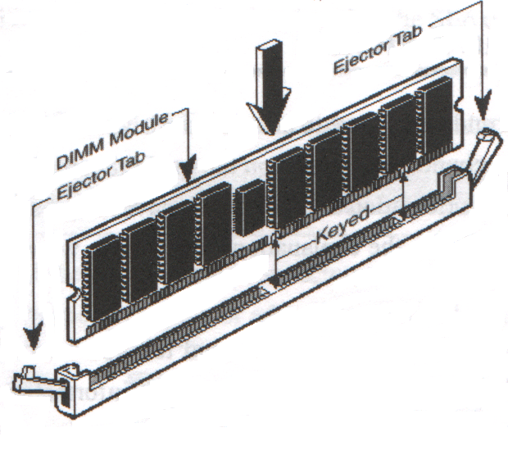
Figure 2-4

NOTE! When you install DIMM module fully into the DIMM socket the eject tab should be locked into the DIMM module very fimly and fit into its indention on both sides.

WARNING! For the SDRAM CLOCK is set at 133MHz, use only PC133-compliant DIMMs. When this motherboard operate at 133Mhz, most system will not even boot if non-compliant modules are used because of the strick timing issues, if your DIMM are not PC133-compliant, set the SDRAM clock to 100MHz to ensure system stability.

2-5 Expansion Cards

WARNING! Turn off your power when adding or removing expansion cards or other system components. Failure to do so may cause severe damage to both your motherboard and expansion cards.

2-5-1 Procedure For Expansion Card Installation

- Read the documentation for your expansion card and make any necessary hardware or software setting for your expansion card such as jumpers.
- Remove your computer’s cover and the bracket plate on the slot you intend to use.
- Align the card’s connectors and press firmly.
- Secure the card on the slot with the screen you remove above.
- Replace the computer system’s cover.
- Set up the BIOS if necessary.
- Install the necessary software driver for your expansion card.

2-5-2 Assigning IRQs For Expansion Card

Some expansion cards need an IRQ to operate. Generally, an IRQ must exclusively assign to one use. In a standard design, there are 16 IRQs available but most of them are already in use.
Standard Interrupt Assignments
IRQ | Priority | Standard function
0 | N/A | System Timer
1 | N/A | Keyboard Controller
2 | N/A | Programmable Interrupt
3 * | 8 | Communications Port (COM2)
4 * | 9 | Communications Port (COM1)
5 * | 6 | Sound Card (sometimes LPT2)
6 * | 11 | Floppy Disk Controller
7 * | 7 | Printer Port (LPT1)
8 | N/A | System CMOS/Real Time Clock
9 * | 10 | ACPI Mode when enabled
10 * | 3 | IRQ Holder for PCI Steering
11 * | 2 | IRQ Holder for PCI Steering
12 * | 4 | PS/2 Compatible Mouse Port
13 | N/A | Numeric Data Processor
14 * | 5 | Primary IDE Channel
15 * | 1 | Secondary IDE Channel
* These IRQs are usually available for ISA or PCI devices.

2-5-3 Interrupt Request Table For This Motherboard

Interrupt request are shared as shown the table below:
 | INT A | INT B | INT C | INT D
PCI slot 1 | Shared | ⎯ | ⎯ | ⎯
PCI slot 2 | ⎯ | Not Shared | ⎯ | ⎯
PCI slot 3 | ⎯ | ⎯ | Shared | ⎯
PCI slot 4 | ⎯ | ⎯ | ⎯ | Shared
PCI slot 5 | Shared | ⎯ | ⎯ | ⎯
AGP slot | Shared | ⎯ | ⎯ | ⎯
AC97/MC97 | ⎯ | ⎯ | Shared | ⎯
Onboard USB | ⎯ | ⎯ | ⎯ | Shared

IMPORTANT! If using PCI cards on shared slots, make sure that the drivers support “Shared IRQ” or that the cards don’t need IRQ assignments. Conflicts will arise between the two PCI groups that will make the system unstable or cards inoperable.

2-5-4 AGP Slot

This motherboard provides an AGP Slot, support the 1X/2X/4X AGP VGA card.

2-6 Connectors, Headers

2-6-1 Connectors

(1) Power Connector (20-pin block) : POWER
ATX Power Supply connector. This is a new defined 20-pins connector that usually comes with ATX case. The ATX Power Supply allows to use soft power on momentary switch that connect from the front panel switch to 2-pins Power On jumper pole on the motherboard. When the power switch on the back of the ATX power supply turned on, the full power will not come into the system board until the front panel switch is momentarily pressed. Press this switch again will turn off the power to the system board.

(2) PS/2 Mouse & PS/2 Keyboard Connector: PS2KB-MS
The connectors for PS/2 keyboard and PS/2 Mouse.
(3) USB Port connector: USB_A
The connectors are 4-pin connector that connect USB devices to the system board.

(4) Parallel Port Connector (25-pin female) : LPT
Parallel Port connector is a 25-pin D-Subminiature Receptacle connector. The On-board Parallel Port can be disabled through the BIOS SETUP. Please refer to Chapter 3 “INTEGRATED PERIPHERALS SETUP” section for more detail information.

(5) Audio and Game Connector : AUD_GAME
This Connector are 3 phone Jack for LINE-OUT, LINE-IN, MIC and a 15-pin
D-Subminiature Receptacle Connector for joystick/MIDI Device.
Line-out : audio output to speaker
Line-in : audio input to sound chip
MIC : Microphone Connector
Game/MIDI : for joystick or MIDI Device
(6) Serial Port COMA, COMB: COM1, COM2
COMA is the 9-pin D-Subminiature mail connector. The On-board serial port can be disabled through BIOS SETUP. Please refer to Chapter 3 “INTEGRATED PERIPHERALS SETUP” section for more detail information.

(7) Floppy drive Connector (34-pin block): FDD
This connector supports the provided floppy drive ribbon cable. After connecting the single plug end to motherboard, connect the two plugs at other end to the floppy drives.
(8) Primary IDE Connector (40-pin block): IDE1
This connector supports the provided IDE hard disk ribbon cable. After connecting the single plug end to motherboard, connect the two plugs at other end to your hard disk(s). If you install two hard disks, you must configure the second drive to Slave mode by setting its jumpers accordingly. Please refer to the documentation of your hard disk for the jumper settings.
(9) Secondary IDE Connector (40-pin block): IDE2
This connector connects to the next set of Master and Slave hard disks. Follow the same procedure described for the primary IDE connector. You may also configure two hard disks to be both Masters using one ribbon cable on the primary IDE connector and another ribbon cable on the secondary IDE connector.
- Two hard disks can be connected to each connector. The first HDD is referred to as the “Master” and the second HDD is referred to as the “Slave”.
- For performance issues, we strongly suggest you don’t install a CD-ROM or DVD-ROM drive on the same IDE channel as a hard disk. Otherwise, the system performance on this channel may drop.

2-6-2 Headers

(1) USB Port Headers (10-pin block): USB_B
These headers are used for connecting the additional USB port plug. By attaching an option USB cable, your can be provided with two additional USB plugs affixed to the back panel.
(2) IDE Activity LED: IDELED
This connector connects to the hard disk activity indicator light on the case.
(3) Turbo LED switch: TBLED
Since the motherboard’s turbo function is always on. The turbo LED will remain constantly on while the system power is on. You may wish to connect the Power LED from the system case to this lead. See the figure below.
(4) Reset switch lead: RESET
This 2-pin connector connects to the case-mounted reset switch for rebooting your computer without having to turn off your power switch. This is a preferred method of rebooting in order to prolong the lift of the system’s power supply. See the figure below.
(5) Speaker connector: SPKR
This 4-pin connector connects to the case-mounted speaker. See the figure below.
(6) Power LED: PWR LED
The Power LED is light on while the system power is on. Connect the Power LED from the system case to this pin.
(7) Power switch: PW BTN
This 2-pin connector connects to the case-mounted power switch to power ON/OFF the system.
(8) Wake On-LAN Headers (3-pin) : WOL
This connector connects to a LAN card with a WAKE ON-LAN output. This connector power up the system when a wake up signal is received through the LAN card.
NOTE: This feature requires that Wake On LAN or Ring In Wake up is enabled.

(9) Wake On-Modem Headers (3-pin) : WOM
This connector connects to a Modem card with a WAKE ON-MODEM output. This connector power up the system when a wake up signal is received through the Modem card.
NOTE: This feature requires that Wake On Modem or Ring In Wake up is enabled.

(10) FAN Speed Headers (3-pin ) : FAN1, FAN2, FAN3
These connectors cupport cooling fans of 350mA (4.2 Watts) or less, depending on the fan manufacturer, the wire and plug may be different. The red wire should be positive, while the black should be ground. Connect the fan’s plug to the board taking into consideration the polarity of connector.

(11) IR infrared module Headers (5-pin) : IR
This connector supports the optional wireless transmitting and receiving infrared module. You must configure the setting through the BIOS setup to use the IR function.

(12) CD Audio-In Headers (4-pin) : CD_IN1, CD_IN2
CD_IN1 and CD_IN2 are the connectors for CD-Audio Input signal. Please connect it to CD-ROM CD-Audio output connector.

2-7 Starting Up Your Computer

- After all connection are made, close your computer case cover.
- Be sure all the switch are off, and check that the power supply input voltage is set to proper position, usually in-put voltage is 220V∼240V or 110V∼120V depending on your country’s voltage used.
- Connect the power supply cord into the power supply located on the back of your system case according to your system user’s manual.
- Turn on your peripheral as following order:
    - Your monitor.
    - Other external peripheral (Printer, Scanner, External Modem etc…)
    - Your system power. For ATX power supplies, you need to turn on the power supply and press the ATX power switch on the front side of the case.
- The power LED on the front panel of the system case will light. The LED on the monitor may light up or switch between orange and green after the system is on. If it compolies with green standards or if it is has a power standby feature. The system will then run power-on test. While the test are running, the BIOS will alarm beeps or additional message will appear on the screen.
If you do not see any thing within 30 seconds from the time you turn on the power. The system may have failed on power-on test. Recheck your jumper settings and connections or call your retailer for assistance.

Beep | Meaning
One short beep when displaying logo | No error during POST
Long beeps in an endless loop | No DRAM install or detected
One long beep followed by three short beeps | Video card not found or video card memory bad
High frequency beeps when system is working | CPU overheated  System running at a lower frequency

- During power-on, press <Delete> key to enter BIOS setup. Follow the instructions in BIOS SETUP.
- Power off your computer: You must first exit or shut down your operating system before switch off the power switch. For ATX power supply, you can press ATX power switching after exiting or shutting down your operating system. If you use Windows 9X, click “Start” button, click “Shut down” and then click “Shut down the computer?” The power supply should turn off after windows shut down.

Chapter 3
Introducing BIOS

The BIOS is a program located on a Flash Memory on the motherboard. This program is a bridge between motherboard and operating system. When you start the computer, the BIOS program gain control. The BIOS first operates an auto-diagnostic test called POST (power on self test) for all the necessary hardware, it detects the entire hardware device and configures the parameters of the hardware synchronization. Only when these tasks are completed done it gives up control of the computer to Operating System (OS). Since the BIOS is the only channel for hardware and software to communicate, it is the key factor for system stability, and in ensuring that your system performance as its best.

In the BIOS Setup main menu of Figure 3-1, you can see several options. We will explain these options step by step in the following pages of this chapter, but let us first see a short description of the function keys you may use here:
- Press <Esc> to quit the BIOS Setup.
- Press ↑↓←→ (up, down, left, right) to choose, in the main menu, the option you want to confirm or to modify.
- Press <F10> when you have completed the setup of BIOS parameters to save these parameters and to exit the BIOS Setup menu.
- Press Page Up/Page Down or +/– keys when you want to modify the BIOS parameters for the active option.

3-1 Entering Setup

Power on the computer and by pressing <Del> immediately allows you to enter Setup.
If the message disappears before your respond and you still wish to enter Setup, restart the system to try again by turning it OFF then ON or pressing the “RESET” button on the system case. You may also restart by simultaneously pressing <Ctrl>, <Alt> and <Delete> keys. If you do not press the keys at the correct time and the system does not boot, an error message will be displayed and you will again be asked to
Press <F1> to continue, <Ctrl-Alt-Esc> or <Del> to enter Setup

3-2 Getting Help

Main Menu
The on-line description of the highlighted setup function is displayed at the bottom of the screen.

Status Page Setup Menu/Option Page Setup Menu
Press F1 to pop up a small help window that describes the appropriate keys to use and the possible selections for the highlighted item. To exit the Help Window, press <Esc>.

3-3 The Main Menu

Once you enter Award BIOS CMOS Setup Utility, the Main Menu (Figure 3-1) will appear on the screen. The Main Menu allows you to select from fourteen setup functions and two exit choices. Use arrow keys to select among the items and press <Enter> to accept or enter the sub-menu.
CMOS Setup Utility – Copyright(C) 1984-2000 Award Software
Standard CMOS Features  Advanced BIOS Features  Advanced Chipset Features  Integrated Peripherals  Power Management Setup  PnP/PCI Configurations  PC Health Status | Miscellaneous Control  Load optimized Defaults  Load Standard Defaults  Set Supervisor Password  Set User Password  Save & Exit Setup  Exit Without Saving
Esc : Quit ↑↓→ ← : Select Item
F10 : Save & Exit Setup
Time, Date, Hard Disk Type...
Figure 3-1
Standard CMOS Features
Use this Menu for basic system configurations.

Advanced BIOS Features
Use this menu to set the Advanced Features available on your system.

Advanced Chipset Features
Use this menu to change the values in the chipset registers and optimize your system’s performance.

Integrated Peripherals
Use this menu to specify your settings for integrated peripherals.

Power Management Setup
Use this menu to specify your settings for power management.

PnP/PCI configurations
This entry appears if your system supports PnP/PCI.

PC Health Status
This entry shows your PC health status.

Miscellaneous Control
Use this menu to specify your settings for Miscellaneous Control.

Load Optimized Defaults
Use this menu to load the BIOS default values that are factory settings for optimal performances system operations.

Load Standard Defaults
Use this menu to load the BIOS default values for the minimal/stable performance system operation.

Set Supervisor/User Password
Use this menu to set User and Supervisor Passwords.

Save & Exit Setup
Save CMOS value changes to CMOS and exit setup.

Exit Without Saving
Abandon all CMOS value changes and exit setup.

3-4 Standard CMOS Features

The items in Standard CMOS Setup Menu are divided into several categories. Each category includes no, one or more than one setup items. Use the arrow keys to highlight the item and then use the <PgUp> or <PgDn> keys to select the value you want in each item.
CMOS Setup Utility – Copyright(C) 1984-2000 Award Software
Standard CMOS Features
Date (mm:dd:yy) Wed, Sep, 13 2000  Time (hh:mm:ss) 13 : 55 : 25  > IDE Primary Master Press Enter None  > IDE Primary Slave Press Enter None  > IDE Secondary Master Press Enter None  > IDE Secondary Slave Press Enter None  Drive A 1.44M, 3.5 in.  Drive B None  Video EGA/VGA  Halt On All Errors  Base Memory 640K  Extended Memory 60416K  Total Memory 61440K | Item Help
Menu Level >

Change the day, month,
year and century

↑↓→← Move Enter:Select Item +/-/PU/PD:Value F10:Save ESC:Exit F1:General Help
F5:Previous Values F6:Optimized Defaults F7:Standard Defaults

Date
The date format is <day><month><date><year>.
Day Day of the week, from Sun to Sat, determined by BIOS. Read-only.
Month The month from Jan. through Dec.
Date The date from 1 to 31 can be keyed by numeric function keys.
Year The year depends on the year of the BIOS.
Time
The time format is <hour><minute><second>.
Primary Master/Primary Slave
Secondary Master/Secondary Slave
Press PgUp/<+> or PgDn/<–> to select Manual, None, Auto type. Note that the specifications of your drive must match with the drive table. The hard disk will not work properly if you enter improper information for this category. If your hard disk drive type is not matched or listed, you can use Manual to define your own drive type manually.

If you select Manual, related information is asked to be entered to the following items. Enter the information directly from the keyboard. This information should be provided in the documentation from your hard disk vendor or the system manufacturer.
If the controller of HDD interface is SCSI, the selection shall be “None”.
If the controller of HDD interface is CD-ROM, the selection shall be “None”
Access Mode The settings are Auto Normal, Large, and LBA.
Cylinder number of cylinders
Head number of heads
Precomp write precomp
Landing Zone landing zone
Sector number of sectors

3-5 Advanced BIOS Features
CMOS Setup Utility – Copyright(C) 1984-2000 Award Software
Advanced BIOS Features
Anti-Virus Protection Disabled  PhoneixNet Support Disabled  CPU L1 Cache Enabled  CPU L2 Cache Enabled  CPU L2 Cache ECC Checking Disabled  Processor Number Feature Disabled  Quick Power On Self Test Enabled  First Boot Device Floppy  Second Boot Device HDD-0  Third Boot Device LS120  Boot other Device Enabled  Swap Floppy Drive Disabled  Boot Up Floppy Seek Enabled  Boot Up NumLock Status On  Gate A20 Option Fast  Typematic Rate Setting Disabled  Typematic Rate (Chars/Sec) 6  Typematic Delay (Msec) 250  Security Option Setup  OS Select For DRAM > 64MB Non-OS2  HDD S.M.A.R.T. Capability Disabled  Video BIOS Shadow Enabled | Item Help
Menu Level >

Allows you to choose
the VIRUS warning
feature for IDE Hard
disk boot sector
protection. If this
function is enabled
and someone attempt to
write data into this
area, BIOS will show a
warning message on
screen and alarm beep
Enabled copies video
BIOS to shadow RAM
Improves
↑↓→← Move Enter:Select Item +/-/PU/PD:Value F10:Save ESC:Exit F1:General Help
F5:Previous Values F6:Optimized Defaults F7:Standard Defaults

Anti-Virus Protection
Allows you to choose the VIRUS Warning feature for IDE Hard Disk boot sector protection. If this function is enabled and someone attempt to write data into this area, BIOS will show a warning message on screen and alarm beep.
Disabled (default) No warning message to appear when anything attempts to access the boot sector or hard disk partition table.
Enabled Activates automatically when the system boots up causing a warning message to appear when anything attempts to access the boot sector of hard disk partition table.
CPU L1 Cache
The default value is Enabled.
Enabled (default) Enable cache
Disabled Disable cache
Note: The internal cache is built in the processor.
CPU L2 Cache
Choose Enabled or Disabled. This option enables the Level 2 cache memory.
CPU L2 Cache ECC Checking
Choose Enabled or Disabled. This option enables the Level 2 cache memory ECC (error check correction).
Processor Number Feature
This option is for Pentium® III processor. During Enabled, this will check the CPU Serial number. Disabled this option if you don’t want the system to know the Serial number.
Quick Powr On Self-Test
This category speeds up Power On Self Test (POST) after you power on the computer. If this is set to Enabled. BIOS will shorten or skip some check items during POST.
Enabled (default) Enable quick POST
Disabled Normal POST
First/Second/Third/Fourth Boot Device
The BIOS attempts to load the operating system from the devices in the sequence selected in these items. The settings are Floppy, LS/ZIP, HDD-0/HDD-1/HDD-3, SCSI, CDROM, LAN and Disabled.
Swap Floppy Drive
Switches the floppy disk drives between being designated as A and B. Default is Disabled.
Boot Up Floppy Seek
During POST, BIOS will determine if the floppy disk drive installed is 40 or 80 tracks. 360K type is 40 tracks while 760K, 1.2M and 1.44M are all 80 tracks.
Boot Up NumLock Status
The default value is On.
On (default) Keypad is numeric keys.
Off Keypad is arrow keys.
Gate A20 Option
Normal The A20 signal is controlled by keyboard controller or chipset hardware.
Fast (default) The A20 signal is controlled by port 92 or chipset specific method.
Typematic Rate Setting
Keystrokes repeat at a rate determined by the keyboard controller. When enabled, the typematic rate and typematic delay can be selected. The settings are: Enabled/Disabled.
Typematic Rate (Chars/Sec)
Sets the number of times a second to repeat a keystroke when you hold the key down. The settings are: 6, 8, 10, 12, 15, 20, 24, and 30.
Typematic Delay (Msec)
Sets the delay time after the key is held down before is begins to repeat the keystroke. The settings are 250, 500, 750, and 1000.
Security Option
This category allows you to limit access to the system and Setup, or just to Setup.
System The system will not boot and access to Setup will be denied if the correct password is not entered at the prompt.
Setup (default) The system will boot, but access to Setup will be denied if the correct password is not entered prompt.
OS Select For DRAM > 64MB
Allows OS2® to be used with >64MB or DRAM. Settings are Non-OS/2 (default) and OS2. Set to OS/2 if using more than 64MB and running OS/2®.
Report No FDD For Win 95
Whether report no FDD for Win 95 or not. The settings are: Yes, No.

3-6 Advanced Chipset Features

The Advanced Chipset Features Setup option is used to change the values of the chipset registers. These registers control most of the system options in the computer.
CMOS Setup Utility – Copyright(C) 1984-2000 Award Software
Advanced Chipset Features
> DRAM Timing Settings Press Enter  > AGP Function Settings Press Enter  In-Order Queue 4-Level  P2C/C2P Concurrency Enabled  Concurrent PCI/Host Enabled  I/O Recovery Time Disabled  CPU to PCI Post Write Enabled  CPU to PCI Dynamic Burst Disabled  PCI Delay Transaction Disabled  Memory Parity/ECC Check Disabled  System BIOS Cacheable Enabled  Video RAM Cacheable Enabled  Memory Hole Disabled | Item Help
 | Menu Level >
↑↓→← Move Enter:Select Item +/-/PU/PD:Value F10:Save ESC:Exit F1:General Help
F5:Previous Values F6:Optimized Defaults F7:Standard Defaults
DRAM Timing Settings
Please refer to section 3-6-1
AGP Function Settings
Please refer to section 3-6-2
Memory Hole
You can reserve this area of system memory for ISA adapter ROM. When this area is reserved, it cannot be cached. The user information of peripherals that need to use this area of system memory usually discusses their memory requirements. The settings are: Enabled and Disabled.
System BIOS Cacheable
Selecting Enabled allows caching of the system BIOS ROM at F0000h-FFFFFh, resulting in better system performance. However, if any program writes to this memory area, a system error may result. The settings are: Enabled and Disabled.
Video RAM Cacheable
Select Enabled allows caching of the video BIOS, resulting in better system performance. However, if any program writes to this memory area, a system error may result. The settings are: Enabled and Disabled.
Memory Parity/ECC Check
This function provides parity check of memory.
The choice is either Disabled or Enabled.
3-6-1 DRAM Timing Settings

CMOS Setup Utility – Copyright(C) 1984-2000 Award Software
DRAM Timing Settings
Auto Configuration Standard  RAS Precharge Time 3T  RAS Active Time 6T  Activate to Command Delay 3T  CAS Latency Auto  Bank Interleave Auto  DRAM Drive Control Auto  Delay DRAM Read Latch 0.5ns  Memory Data Drive Normal  SDRAM Command Drive Weak | Item Help
 | Menu Level >>
↑↓→← Move Enter:Select Item +/-/PU/PD:Value F10:Save ESC:Exit F1:General Help
F5:Previous Values F6:Optimized Defaults F7:Standard Defaults

RAS Precharge Time
If an insufficient number of cycles is allowed for the RAS to accumulate its charge before DRAM refresh, the refresh may be incomplete and the DRAM may fail to retain date. Fast gives faster performance; and Slow gives more stable performance. This field applies only when synchronous DRAM is installed in the system. The settings are: Auto, 2 and 3.

Activate To Command Delay
This field let’s you insert a timing delay between the CAS and RAS strobe signals, used when DRAM is written to, read from, or refreshed. Fast gives faster performance; and Slow gives more stable performance. This field applies only when synchronous DRAM is installed in the system. The settings are: Auto, 2T and 3T.

RAS Active Time
Select the number of SCLKs for an access cycle. The settings are: Auto, 5T and 6T.

CAS Latency
When synchronous DRAM is installed, the number of clock cycles of CAS latency depends on the DRAM timing. The settings are: 2 and 3.

DRAM Drive Control
This field let’s you choose the Memory Address, Memory Data drive current to suit your SDRAM Module, the Default setting is Auto.

3-6-2 AGP Function Settings

CMOS Setup Utility – Copyright(C) 1984-2000 Award Software
AGP Function Settings
AGP Rate Auto  AGP Aperture Size 64M  AGP Driving Control Auto  AGP Driving Value DA  AGP Fast Write Disabled  AGP Master 1 WS Write Enabled  AGP Master 1 WS Read Enabled | Item Help
 | Menu Level >>
↑↓→← Move Enter:Select Item +/-/PU/PD:Value F10:Save ESC:Exit F1:General Help
F5:Previous Values F6:Optimized Defaults F7:Standard Defaults
Note: Change these settings only if you are familiar with the chipset.

3-7 Integrated Peripherals
CMOS Setup Utility – Copyright(C) 1984-2000 Award Software
Integrated Peripherals
> OnChip IDE Function Press Enter  > OnChip SIO Function Press Enter  > OnChip Device Function Press Enter  Init Display First PCI Slot | Item Help
 | Menu Level >
↑↓→← Move Enter:Select Item +/-/PU/PD:Value F10:Save ESC:Exit F1:General Help
F5:Previous Values F6:Optimized Defaults F7:Standard Defaults
OnChip IDE Function
Please refer to section 3-7-1
OnChip SIO Function
Please refer to section 3-7-2
OnChip Device Function
Please refer to section 3-7-3
Init Display First
This item allows you to decide to activate whether PCI Slot or AGP VGA first. The settings are: PCI Slot, AGP Slot.

3-7-1 OnChip IDE Function
CMOS Setup Utility – Copyright(C) 1984-2000 Award Software
OnChip IDE Function
OnChip IDE Channel0 Enabled  OnChip IDE Channel1 Enabled  Primary Master PIO Auto  Primary Slave PIO Auto  Secondary Master PIO Auto  Secondary Slave PIO Auto  Primary Master UDMA Auto  Primary Slave UDMA Auto  Secondary Master UDMA Auto  Secondary Slave UDMA Auto  IDE 32-bit Transfer Mode Enabled  IDE HDD Block Mode Enabled  IDE Prefetch Mode Enabled  Delay For HDD (Secs) 0 | Item Help
 | Menu Level >>
↑↓→← Move Enter:Select Item +/-/PU/PD:Value F10:Save ESC:Exit F1:General Help
F5:Previous Values F6:Optimized Defaults F7:Standard Defaults
OnChip IDE Channal0/Channel1
The integrated peripheral controller contains an IDE interface with support for two IDE channels. Select Enabled to activate each channel separately. The settings are: Enabled and Disabled.
Primary/Secondary Master/Slave PIO
The four IDE PIO (Programmed Input/Output) fields let you set a PIO mode (0-4) for each of the four IDE devices that the onboard IDE interface supports. Modes 0 through 4 provide successively increased performance. In Auto mode, the system automatically determines the best mode for each device. The settings are: Auto, Mode 0, Mode 1, Mode 2, Mode 3, Mode 4.
Primary/Secondary Master/Slave UDMA
Ultra DMA/33 implementation is possible only if your IDE hard drive supports it and the operating environment includes a DMA driver (Windows 95 OSR2 or a third-party IDE bus master driver). If your hard drive and your system software both support Ultra DMA 33/66/100, select Auto to enable BIOS support. The settings are: Auto, Disabled.
IDE HDD Block Mode
Block mode is also called block transfer, multiple commands, or multiple sector read/write. If your IDE hard drive supports block mode (most new drives do), select Enabled for automatic detection of the optimal number of block read/writes per sector the drive can support. The settings are: Enabled, Disabled.

3-7-2 OnChip SIO Function

CMOS Setup Utility – Copyright(C) 1984-2000 Award Software
OnChip SIO Function
Onboard FDD Controller Enabled  Onboard Serial Port 1 Auto  Onboard Serial Port 2 Auto  UART 2 Mode Normal  IR Duplex Mode Half  TX,RX inverting enable No, Yes  Onboard Parallel Port 378/IRQ7  Onboard Parallel Mode Normal  Parallel Port EPP Type EPP1.9  ECP Mode Use DMA 3 | Item Help
 | Menu Level >>
↑↓→← Move Enter:Select Item +/-/PU/PD:Value F10:Save ESC:Exit F1:General Help
F5:Previous Values F6:Optimized Defaults F7:Standard Defaults
Onboard FDD Controller
Select Enabled if your system has a floppy disk controller (FDD) installed on the system board and you wish to use it. If you install add-on FDC or the system has no floppy drive, select Disabled in this field. The settings are: Enabled and Disabled.

Onboard Serial Port 1/Port 2
Select an address and corresponding interrupt for the first and the second serial ports. The settings are: 3F8/IRQ4, 2E8/IRQ3, 3E8/IRQ4, 2F8/IRQ3, Disabled, Auto.

UART 2 Mode
This item allows you to determine which InfraRed(IR) function of the onboard I/O chip, this functions uses.

Onboard Parallel Port
There is a built-in parallel port on the on-board Super I/O chipset that Provides Standard, ECP, and EPP features. It has the following option:
Disabled
(3BCH/IRQ7)/ Line Printer port 0
(278H/IRQ5)/ Line Printer port 2
(378H/IRQ7) Line Printer port 1

Onboard Parallel Mode
SPP : Standard Parallel Port
EPP : Enhanced Parallel Port
ECP : Extended Capability Port

SPP/EPP/ECP/ECP+EPP
To operate the onboard parallel port as Standard Parallel Port only, choose “SPP.” To operate the onboard parallel port in the EPP modes simultaneously, choose “EPP.” By choosing “ECP”, the onboard parallel port will operate in ECP mode only. Choosing “ECP+EPP” will allow the onboard parallel port to support both the ECP and EPP modes simultaneously. The ECP mode has to use the DMA channel, so choose the onboard parallel port with the ECP feature. After selecting it, the following message will appear: “ECP Mode Use DMA” at this time, the user can choose between DMA channels 3 to 1. The onboard parallel port is EPP Spec. compliant, so after the user chooses the onboard parallel port with the EPP function, the following message will be displayed on the screen: “EPP Mode Select.” At this time either EPP 1.7 spec. or EPP 1.9 spec. can be chosen.

3-7-3 OnChip Device Function
CMOS Setup Utility – Copyright(C) 1984-2000 Award Software
OnChip Device Function
> OnChip Sound Function Press Enter  USB Host Controller Enabled  USB Keyboard Support Disabled  USB Mouse Support Disabled  AC97 Modem Device Enabled | Item Help
 | Menu Level >>
↑↓→← Move Enter:Select Item +/-/PU/PD:Value F10:Save ESC:Exit F1:General Help
F5:Previous Values F6:Optimized Defaults F7:Standard Defaults

OnChip Sound Function
Please refer to section 3-7-3.1
USB Host Controller
Select Enabled if your system contains a Universal Serial Bus (USB) controller and you have a USB peripherals. The settings are: Enabled, Disabled.
USB Keyboard/Mouse Support
Select Enabled if your system contains a Universal Serial Bus (USB) controller and you have a USB Keyboard/Mouse. The settings are: Enabled, Disabled.
AC97 Modem Device
This item allows you to decide to enable/disable the VIA 82686B chipset family to support AC97 Modem. The settings are: Auto, Disabled.

3-7-3.1 OnChip Sound Function

CMOS Setup Utility – Copyright(C) 1984-2000 Award Software
OnChip Sound Function
AC97 Sound Device Enabled  Sound Blaster Disabled  SB I/O Base Address 220H  SB IRQ Select IRQ 5  SB DMA Select DMA 1  MPU-401 Enabled  MPU-401 I/O Address 330-333H  Game Port (200-207H) Enabled | Item Help
 | Menu Level >>>
↑↓→← Move Enter:Select Item +/-/PU/PD:Value F10:Save ESC:Exit F1:General Help
F5:Previous Values F6:Optimized Defaults F7:Standard Defaults
AC97 Sound Device
This item allows you to decide to enable/disable the VIA 82686B chipset family to support AC97 Audio. The settings are: Enabled, Disabled.
Game Port (200-207H)
This item allows you enabled or disabled on board Game Port.

3-8 Power Management Setup

The Power Management Setup allows you to configure your system to most effectively save energy saving while operating in a manner consistent with your own style of computer use.
CMOS Setup Utility – Copyright(C) 1984-2000 Award Software
Power Management Setup
ACPI Function Enabled  > Power Management Press Enter  PM Control by APM Yes  Video Off Option Suspend -> off  Video off Method V/H SYNC+Blank  MODEM Use IRQ 3  Power Button Function Instant-off  Power Loss Function Off  > Wake-Up Events Press Enter | Item Help
 | Menu Level >
↑↓→← Move Enter:Select Item +/-/PU/PD:Value F10:Save ESC:Exit F1:General Help
F5:Previous Values F6:Optimized Defaults F7:Standard Defaults

ACPI Function
This item allows you to Enabled/Disabled the Advanced Configuration and Power Management (ACPI). The settings are Enabled and Disabled.
Power Management
Please refer to section 3-8-1
Video Off Option
This determines the manner in which the monitor is blanked. The choice are Suspend → off, All Modes → Off, and Always On.
Video Off Method
This determines the manner in which the monitor is blanked.
DPMS (default) Initial display power management signaling.
Blank Screen This option only writes blanks to the video buffer.
V/H SYNC+Blank This selection will cause the system to turn off the vertical and horizontal synchronization ports and write blanks to the video buffer.
Modem Use IRQ
This determines the IRQ in which the MODEM can use.
The settings are: 3, 4, 5, 7, 9, 10, 11, NA.
Soft-off by PWRBTN
Pressing the power button for more than 4 seconds forces the system to enter the Soft-Off state. The settings are: Delay 4 Sec, Instant-Off.
Wake-Up Events
Please refer to section 3-8-2

3-8-1 Power Management
CMOS Setup Utility – Copyright(C) 1984-2000 Award Software
Power Management
Power Management User Define  HDD Power Down Disabled  Doze Mode Disabled  Suspend Mode Disabled | Item Help
 | Menu Level >>
↑↓→← Move Enter:Select Item +/-/PU/PD:Value F10:Save ESC:Exit F1:General Help
F5:Previous Values F6:Optimized Defaults F7:Standard Defaults

Power Management
This category allows you to select the type (or degree) of power saving which is directly related to the following modes:
User Define(default) Allows you to set each mode individually. When not disabled, each of the ranges is from 1 min. to 1hr. except for HDD Power Down that ranges from 1 min. to 15 min. and disable.
Min Saving Minimum power management. Doze Mode 1H, Suspend Mode=1 hr., Power Down=15 min.
Max Saving Maximum power management. Doze Mode 1H, Suspend Mode=1 min., Power Down=1 min.
HDD Power Down
When enabled and after setting time of system inactivity, the hard disk drive will be powered down while all the other devices remain active.
The settings are: 1/2/3/4/5/6/7/8/9/10/11/12/13/14/15 Min and Disabled.
Suspend Mode
When enabled and after the set time of system inactivity, all devices except the CPU will be shut off.
The settings are: l/2/4/8/12/20/30/40 Min, 1 Hour, and Disabled.
3-8-2 Wake up Events

CMOS Setup Utility – Copyright(C) 1984-2000 Award Software
Wake Up Events
VGA OFF  LPT & COM LPT/COM  HDD & FDD ON  DMA/Master OFF  Wake-Up On Ring/LAN(WOL) Disabled  Wake-Up On PCI PME Disabled  Wake-Up RTC Alarm Disabled  Date of Month Alarm 0  Time (hh:mm:ss) Alarm 0 : 0 : 0  > IRQs Activity Press Enter | Item Help
 | Menu Level >>
↑↓→← Move Enter:Select Item +/-/PU/PD:Value F10:Save ESC:Exit F1:General Help
F5:Previous Values F6:Optimized Defaults F7:Standard Defaults
Wak-Up On PCI PME
This will enable the system to wake up by PCI Card.
The settings are: Enabled and Disabled.

Wake-Up On Ring/LAN(WOL)
During Disabled, the system will ignore any incoming call from the modem. During Enabled, the system will boot up if there’s an incoming call from the modem.
Wake-Up On RTC Alarm
This function is for setting date and time for your computer to boot up. During Disabled, you cannot use this function. During Enabled, choose the Date and Time Alarm:
Date(of month) Alarm
You can choose which month the system will boot up. Set to 0, to boot every day.
Time(hh:mm:ss) Alarm
You can choose what hour, minute and second the system will boot up.
Note: If you have change the setting, you must let the system boot up until it goes to the operating system, before this function will work.

IRQs Activity
Please refer to section 3-8-2.1

3-8-2.1 IRQs Activity

CMOS Setup Utility – Copyright(C) 1984-2000 Award Software
IRQs Activity
Primary INTR On  IRQ3 (COM 2) Primary  IRQ4 (COM 1) Primary  IRQ5 (LPT 2) Primary  IRQ6 (Floppy Disk) Primary  IRQ7 (LPT 1) Primary  IRQ8 (RTC Alarm) Disabled  IRQ9 (IRQ2 Redir) Secondary  IRQ10 (Reserved) Secondary  IRQ11 (Reserved) Secondary  IRQ12 (PS/2 Mouse) Primary  IRQ13 (Coprocessor) Primary  IRQ14 (Hard Disk) Primary  IRQ15 (Reserved) Disabled | Item Help
 | Menu Level >>>
↑↓→← Move Enter:Select Item +/-/PU/PD:Value F10:Save ESC:Exit F1:General Help
F5:Previous Values F6:Optimized Defaults F7:Standard Defaults

3-9 PnP/PCI Configuration Setup

This section describes configuring the PCI bus system. PCI, or Personal Computer Interconnect, is a system which allows I/O devices to operate at speeds nearing the speed the CPU itself uses when communicating with its own special components. This section covers some very technical items and it is strongly recommended that only experienced users should make any changes to the default settings.
CMOS Setup Utility – Copyright(C) 1984-2000 Award Software
PnP/PCI Configurations
PnP OS Installed No  Reset Configuration Data Disabled  Resources Controlled By Manual  x IRQ Resources Press Enter  x DMA Resources Press Enter  PCI/VGA Palette Snoop Disabled  Assign IRQ For VGA Enabled  Assign IRQ For USB Enabled | Item Help
Menu Level >

Select Yes if you are
using a Plug and Play
capable operating
system Select No if
you need the BIOS to
configure non-boot
devices
↑↓→← Move Enter:Select Item +/-/PU/PD:Value F10:Save ESC:Exit F1:General Help
F5:Previous Values F6:Optimized Defaults F7:Standard Defaults
Reset Configuration Data
Normally, you leave this field Disabled. Select Enabled to reset Extended System Configuration Data (ESCD) when you exit Setup if you have installed a new add-on and the system reconfiguration has caused such a serious conflict that the operating system can not boot. The settings are: Enabled and Disabled.
Resource Controlled By
The Award Plug and Play BIOS has the capacity to automatically configure all of the boot and Plug and Play compatible devices. However, this capability means absolutely nothing unless you are using a Plug and Play operating system such as Windows®95/98. If you set this field to “manual” choose specific resources by going into each of the sub menu that follows this field (a sub menu is preceded by a “>”).
The settings are: Auto(ESCD), Manual.
IRQ Resources
When resources are controlled manually, assign each system interrupt a type, depending on the type of device using the interrupt.
DMA Resources
This sub menu can let you control the DMA resource.
PCI/VGA Palette Snoop
Leave this field at Disabled. The settings are Enabled, Disabled.

3-10 PC Health Status

This section shows the Status of you CPU, Fan, Warning for overall system status. This is only available if there is Hardware Monitor onboard.

CMOS Setup Utility – Copyright(C) 1984-2000 Award Software
PC Health Status
Show PC Health in Post Enabled  Vcore 1.91V  2.5V 2.50V  3.3V 3.40V  5V 5.10V  12V 11.95V  Current CPU Temp. 33°C/91°F  Current System Temp. 21°C/69°F  Current CPUFAN1 Speed 5100 RPM  Current CPUFAN2 Speed 0 | Item Help
 | Menu Level >
↑↓→← Move Enter:Select Item +/-/PU/PD:Value F10:Save ESC:Exit F1:General Help
F5:Previous Values F6:Optimized Defaults F7:Standard Defaults
Show PC Health in Post
During Enabled, it displays information list below. The choice is either Enabled or Disabled
Current CPU Temperature/Current System Temp/Current FAN1, FAN2 Speed/Vcore/ Vdd/3.3V/+5V/+12V (V)
This will show the CPU/FAN/System voltage chart and FAN Speed.

3-11 Miscellaneous Control

This section is for setting CPU Miscellaneous Control.

CMOS Setup Utility – Copyright(C) 1984-2000 Award Software
Miscellaneous Control
CyrixIII Clock Ratio Default  Auto Detect DIMM/PCI Clock Enabled  Spread Spectrum Disabled  ** Current Host Clock is 66Mhz **  Host Clock at Next Boot is 66Mhz  ** Current DRAM Clock is 66Mhz **  DRAM Clock at Next Boot is 66Mhz (HOST CLK) | Item Help
Menu Level >

CyrixIII CPU Ratio
Adjustment
↑↓→← Move Enter:Select Item +/-/PU/PD:Value F10:Save ESC:Exit F1:General Help
F5:Previous Values F6:Optimized Defaults F7:Standard Defaults

Auto Detect DIMM/PCI Clock
This item allows you to enable/disable auto detect DIMM/PCI Clock.
The settings are: Enabled, Disabled.
Spread Spectrum
This item allows you to set the CPU Host/PCI clock Spread Spectrum.
The choice are: Disabled and Enabled.
Host Clock at Next Boot is
This item allows you to step by step setting CPU/HOST Frequency, USE PageDown/ PageUp key user can change the frequency to approach overclocking.
DRAM Clock at Next Boot is
This item allows you to select SDRAM Frequency to add or to decrease.

3-12 Load Standard/Optimized Defaults

Load Standard Defaults
When you press <Enter> on this item, you get confirmation dialog box with a message similar to:
Load Standard Defaults (Y/N)? N
Pressing <Y> loads the BIOS default values for the most stable, minimal-performance system operations.
Load Optimized Defaults
When you press <Enter> on this item, you get a confirmation dialog box with a message similar to:
Load Optimized Defaults (Y/N)? N
Pressing <Y> loads the default values that are factory settings for optimal performance system operations.

3-13 Set Supervisor/User Password

You can set either supervisor or user password, or both of them. The differences are:
Supervisor password: Can enter and change the options of the setup menus.
User password: Can only enter but do not have the right to change the options of the setup menus. When you select this function, the following message will appear at the center of the screen to assist you in creating a password.
ENTER PASSWORD:
Type the password, up to eight characters in length, and press <Enter>. The password typed now will clear any previously entered password from CMOS memory. You will be asked to confirm the password. Type the password again and press <Enter>. You may also press <Esc> to abort the selection and not enter a password.
To disable a password, just press <Enter> when you are prompted to enter the password. A message will confirm that the password will be disabled. Once the password is disabled, the system will boot and you can enter Setup freely.
PASSWORD DISABLED.
When a password has been enabled, you will be prompted to enter it every time you try to enter Setup. This prevents an unauthorized person from changing any part of your system configuration.
Additionally, when a password is enabled, you can also require the BIOS to request a password every time your system is rebooted. This would prevent unauthorized use of your computer.
You determine when the password is required within the BIOS Features Setup Menu and its Security option. If the Security option is set to “System”, the password will be required both at boot and at entry to Setup. If set to “Setup”, prompting only occurs when trying to enter Setup.

Chapter 4
DRIVER & FREE PROGRAM INSTALLATION

Check your package and there is A MAGIC INSTALL CD included. This CD consists of all DRIVERS you need and some free application programs and utility programs. In addition, this CD also include an auto detect software which can tell you which hardware is installed, and which DRIVERS needed so that your system can function properly. We call this auto detect software MAGIC INSTALL.

MAGIC INSTALL supports WINDOWS 95/98/98SE/NT4.0/2000

Insert CD into your CD-ROM drive and the MAGIC INSTALL Menu should appear as below. If the menu does not appear, double-click MY COMPUTER / double-click CD-ROM drive or click START / click RUN / type X:\SETUP.EXE (assuming X is your CD-ROM drive).
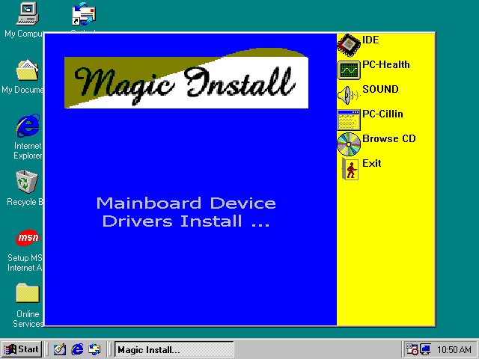

From MAGIC INSTALL MENU you may make 6 selections:
1. IDE install VIA Service Pack 4 IN 1 driver
2. PC-HEALTH install VIA PC-HEALTH hardware monitor driver
3. SOUND install AC97 Audio Codec Installing driver
4. PC-CILLIN install PC-CILLIN98 anti-virus program
5. BROWSE CD to browse the contents of the CD
6. EXIT to exit from MAGIC INSTALL menu

4-1 IDE Install VIA Service Pack 4 IN 1 Driver

IDE : VIA ATAPI VENDOR SUPPORT DRIVER IS USED TO FIXED COMPATIBILITY ISSUE FOR IDE DEVICES
AGPVXD : VIA AGPVXD DRIVER IS TO BE INSTALLED, IF YOU ARE USING AN AGP VGA CARD, VIAGART.VXD WILL PROVIDE SERVICE ROUTINES TO YOUR VGA DRIVER AND INTERFACE DIRECTLY TO HARDWARE, PROVIDING FAST GRAPHIC ACCESS
IRQ ROUTING : VIA PCI IRQ MINIPORT DRIVER IS TO BE INSTALLED UNDER WIN98 ONLY, IT WILL FIX PCI IRQ ROUTING SEQUENCE
INF : VIA REGISTRY DRIVER IS TO BE INSTALLED UNDER WINDOWS
THE DRIVER WILL ENABLE VIA POWER MANAGERMENT CONTROLLER

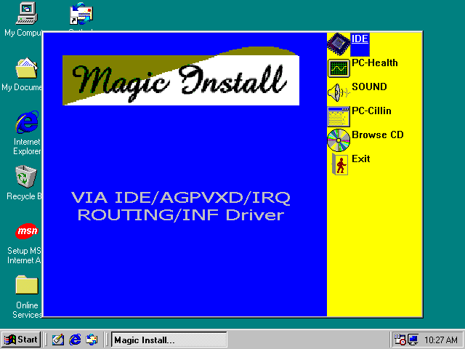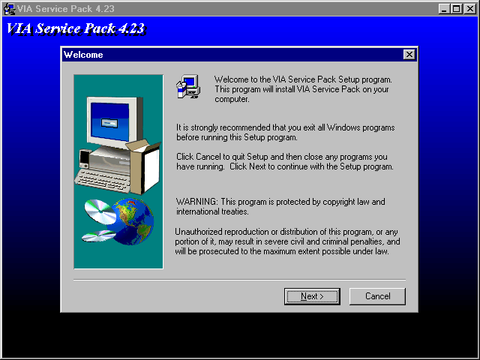
- Click IDE when MAGIC INSTALL MENU appears | - Click NEXT when VIA Service Pack Wizard appears

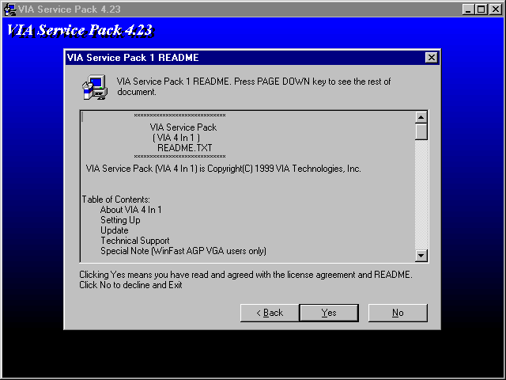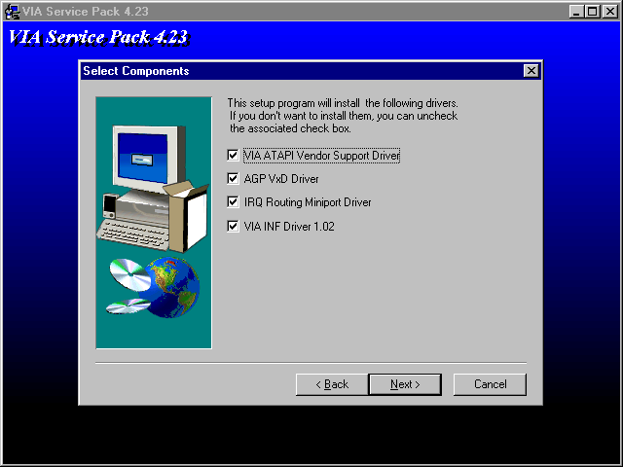
- This is to announce the Copy Write, click NEXT | - Click NEXT to choose all driver

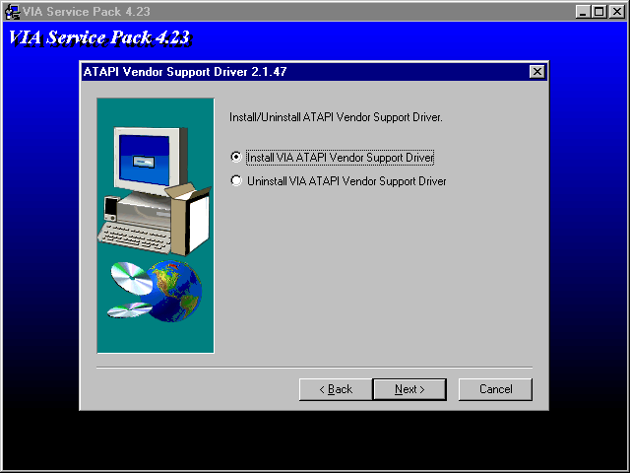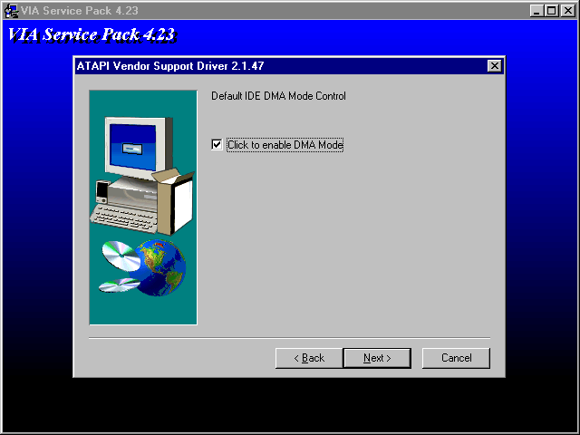
- Click NEXT to Install ATAPI Vender Support Driver | - Click NEXT to choose enabled DMA Mode

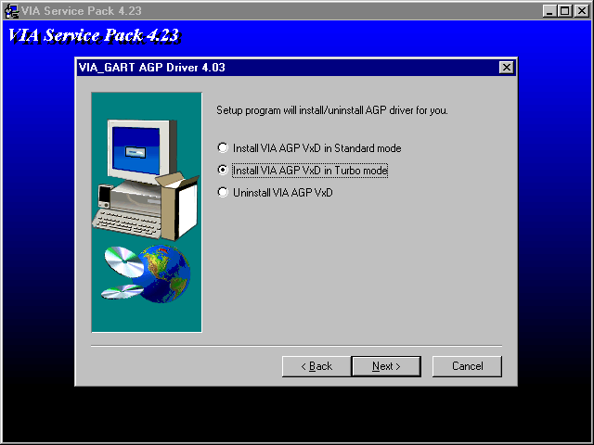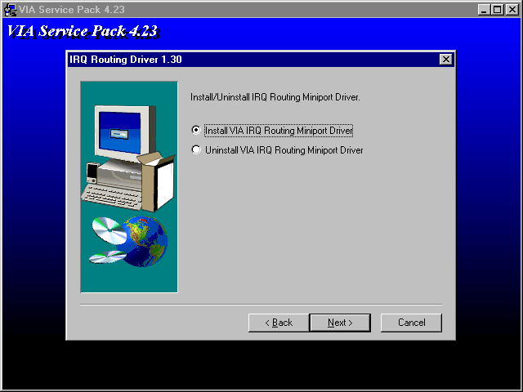
- Click NEXT to Install VIA AGP VXD Driver | - Click NEXT to Install VIA IRQ Routing Mini port Driver

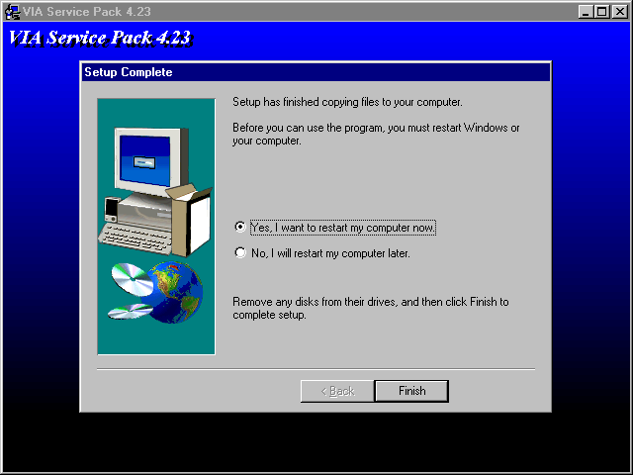
- Click Finish to restart computer

4-2 PC-HEALTH Install VIA Hardware Monitor Driver

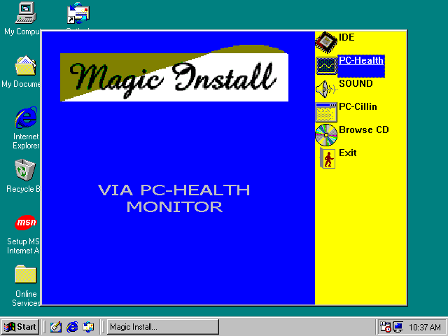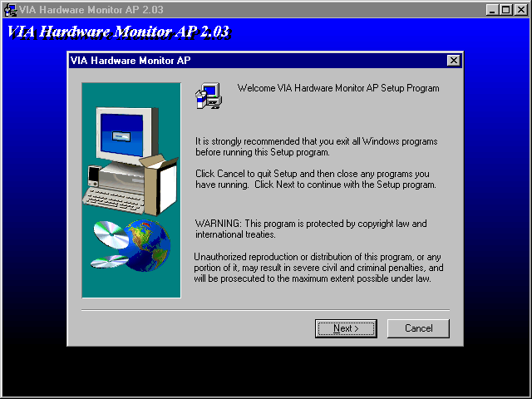
- Click PC-HEALTH when Magic Install MENU appears | - Click NEXT when VIA Hardware Monitor Wizard appears

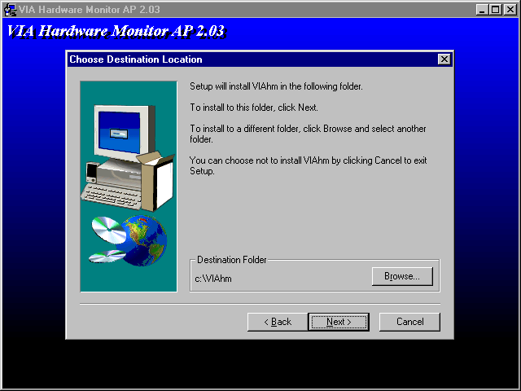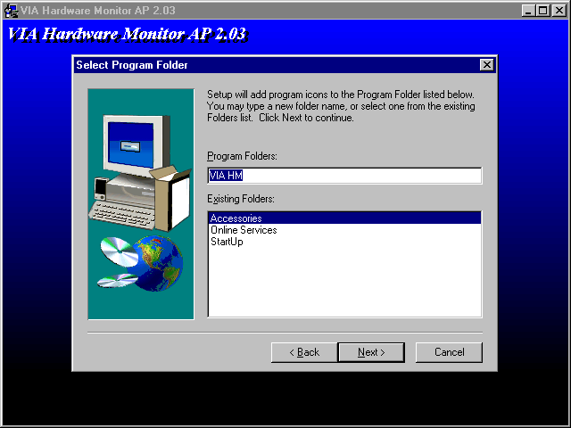
- Click Next to install Driver in C:\VIAHM | - Click Next to use default Program Folders name
4-2-1 How To Use VIA Hardware Monitor Application Software

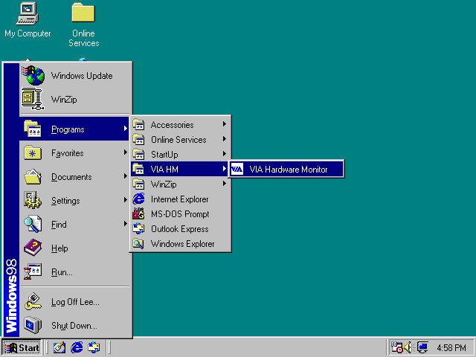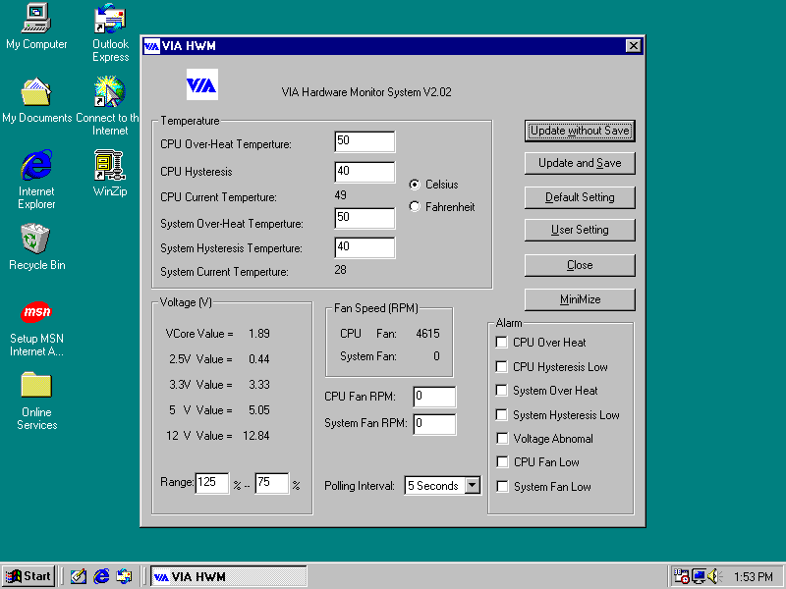
- Click Programs, VIA HM and will show next screen
4-3 Sound VIA AC97 Audio Codec Installing Driver

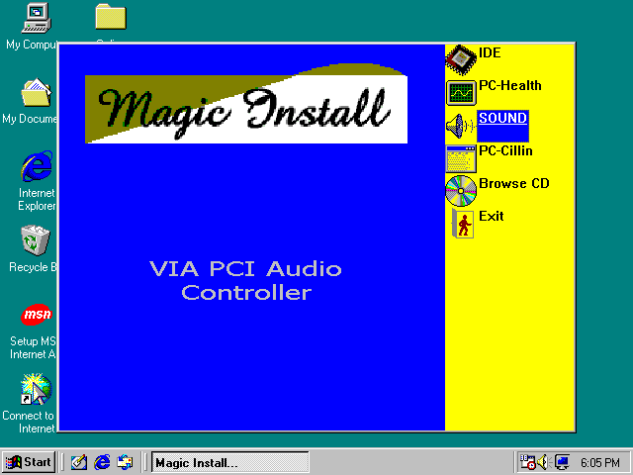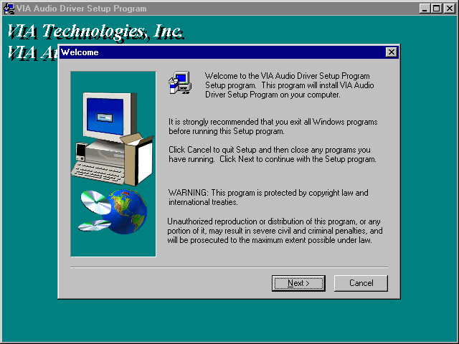
- Click SOUND when Magic Install MENU appears | - Click Next when VIA Audio Driver Wizard appears

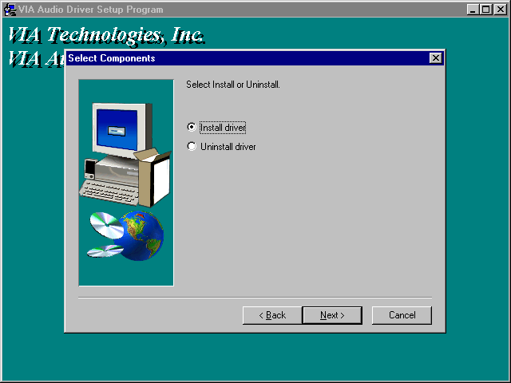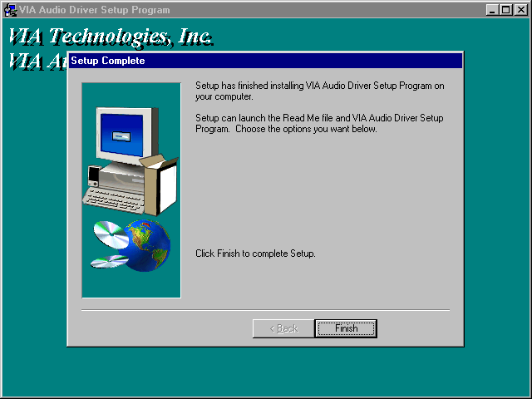
- Click Next to Install VIA Audio Driver | - After Copy files please click finish to finish Installing
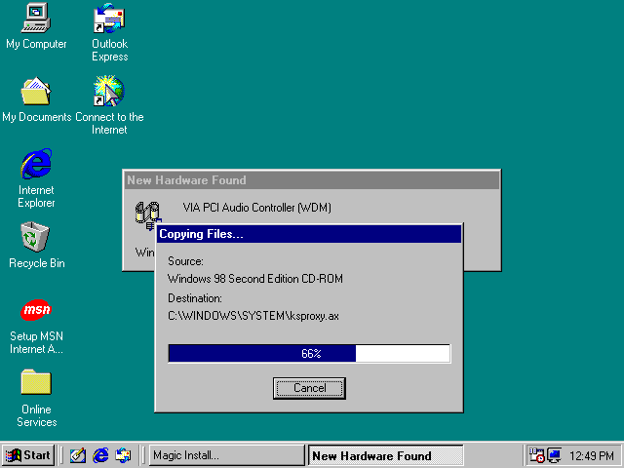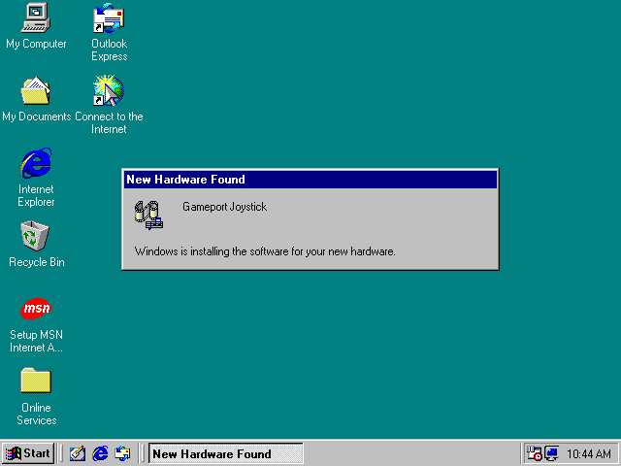
- System will Auto detect and find the device to copy driver | - Wait about 10∼20 sec system will auto Install Game port Joystick driver

4-4 PC-CILLIN install PC-CILLIN98 anti-virus program

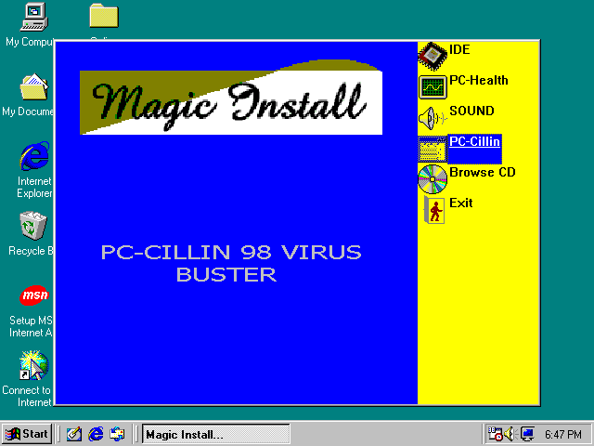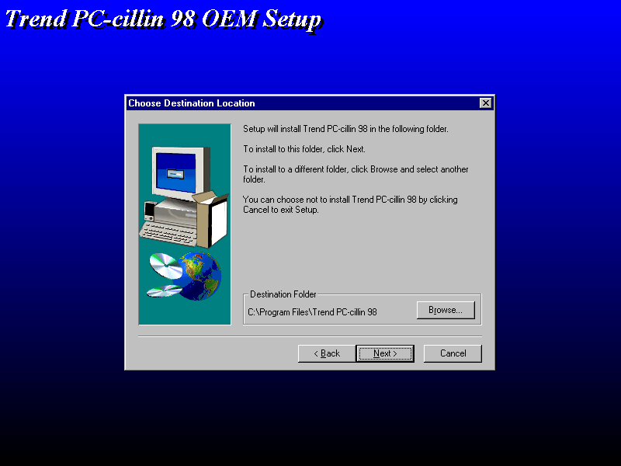
- Click PC-CILLIN when MAGIC INSTALL MENU Appears | - Click NEXT when PC-CILIN 98 OEM SETUP APPEARS. Then click YES when the announcement of copywrite appears. Software is starting to detect HD for virus

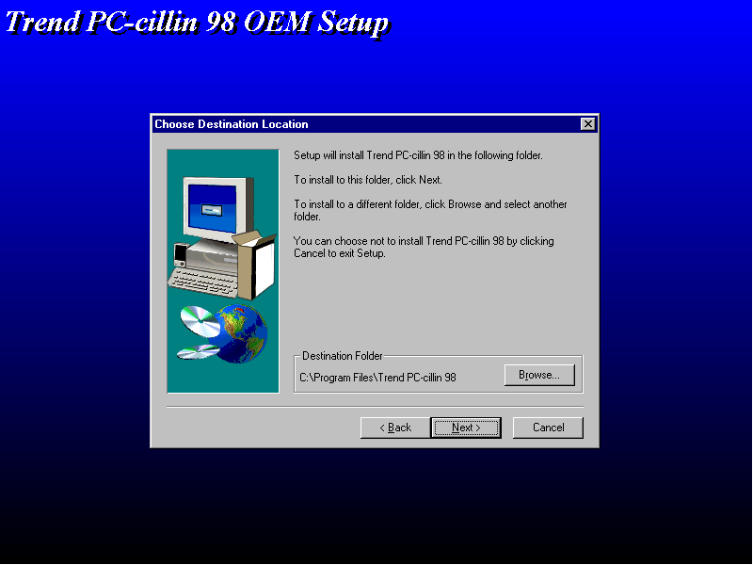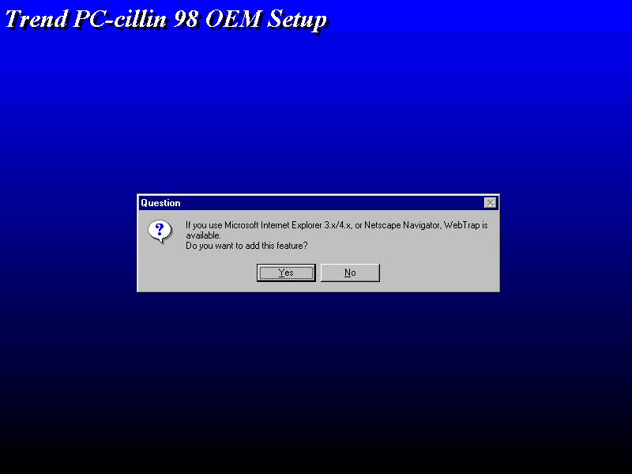
- Click NEXT or choose BROWSE to change the path For the file to be stored | - Start to install the software, choose YES or NO when asked if you want PC-CILLIN To be added in ACTIVE CHANNEL or in Your internet browser
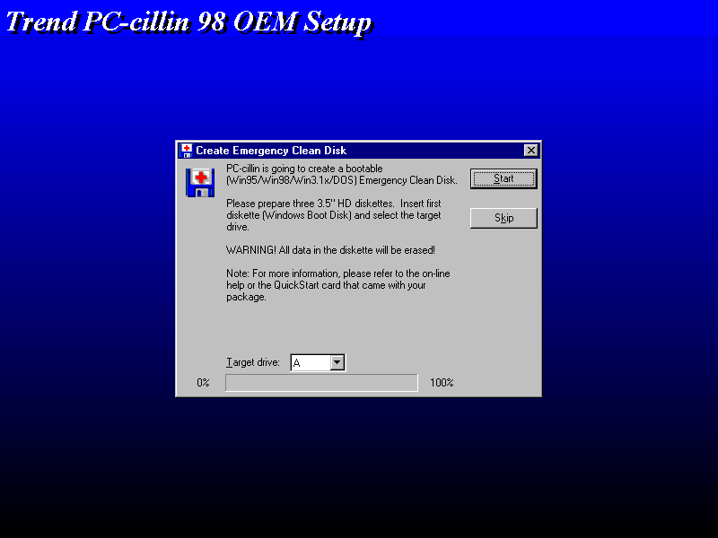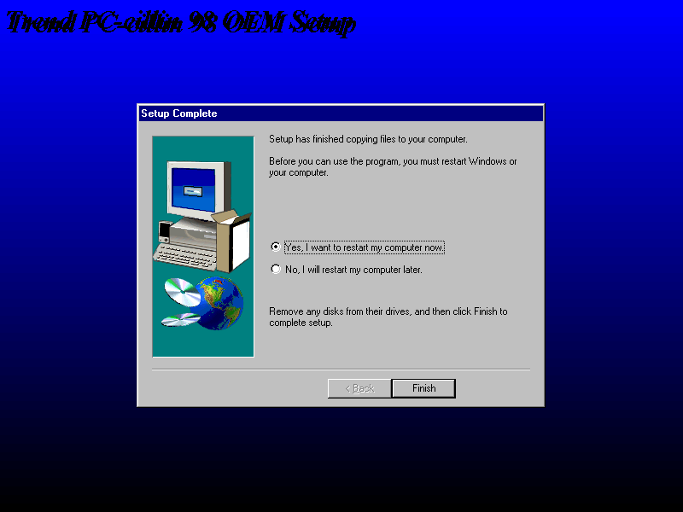
- If you want to make a rescue disc, insert a 1.44 MB disk | - Choose if you want to re-start and click Finish

4-5 HOW TO DISABLE ON-BOARD SOUND

Enter BIOS SETUP choose INTEGRATE PERIPHERALS choose ON-CHIP DEVICE FUNCTION choose AC97 SOUND DEVICE
Disable on-board sound function by press PAGE DOWN KEY to Disable

4-6 HOW TO UPDATE BIOS

STEP 1. Prepare a boot disc. (you may make one by click START click RUN type SYS A: click OK)
STEP 2. Copy utility program to your boot disc. You may copy from DRIVER CD X:\FLASH\AWDFLASH.EXE or download from our web site.
STEP 3. Copy latest BIOS for 694TAS from our web site to your boot disc.
STEP 4. Insert your boot disc into A:,
start the computer, type “Awdflash A:\694TASxxx.BIN /SN /PY /CC /R”
694TASxxx.BIN is the file name of latest BIOS it can be 694TASA03.BIN or 694TASB02.BIN
SN means don’t save existing BIOS data
PY means renew existing BIOS data
CC means clear existing CMOS data
R means restart computer
STEP 5. Push ENTER and the BIOS will be updated, computer will be restarted automatically

