Chapter 4

Software & Applications

Introduction
The support software CD-ROM included in the mainboard package contains all the drivers and utilities as needed to use our products. Below you can find a brief description of each software program, and the right location for your mainboard. More information on each individual software might be available in a README file, located in the same directory as the software.
If the operating system used in your system is Windows 98, it will automatically install all the drivers and utilities for your board. See the Auto-Installing under Windows 98 section.

Installing the Drivers
The software on the support CD-ROM is for Windows 95/NT/2000 and Windows 98, but the automatic installation is now for Win98 only. If your operating system is not Windows 98, you have to manually install for your drivers.

Installing Under Windows 95/NT/2000
- In order to run the software put the support software CD-ROM in the CD-ROM drive.
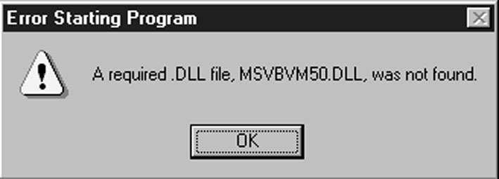
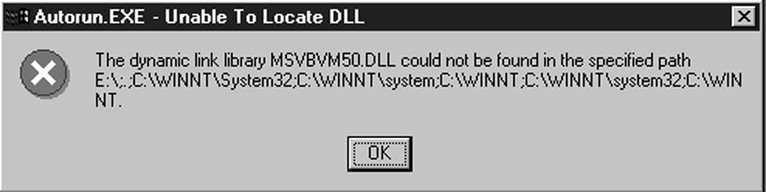
- If your operating system is Windows 95/NT, the system might get an error message as one of two pictures below from the PnP function.
Don’t care the message, and click the OK button to exit. You don’t really need the file to install the drivers.
If your operating system is Windows 2000, exit the Auto Set Up window and go on.
- Use either My Computer or Windows Explorer to look at the directory structure. You must use the Open command. Double-clicking on the drive icon will not work.
- Execute the EXE file name given in the description below.

Note: The correct path name for each software driver is provided, where D: identifies the CD-ROM drive letter – modify if necessary.

Bus Master IDE Driver
The IDE Bus Master Drivers allows the system to properly manage the IDE channels on the mainboard. You need to install two IDE drivers if you are running Windows 9x.
- Windows 9x – D:\IDE\Intel810\WIN9x\Intelinf\SETUP.EXE, and then, D:\IDE\Intel810\WIN9x\Infinst\SETUP.EXE

USB Driver
The USB Driver allows the system to recognize the USB ports on the mainboard. You need to install this driver if you are running Windows 95. This driver is available for:
- Win95 – D:\USB\EUSBSUPP\USBSUPP.EXE
- Win95 (Chinese) – D:\USB\CUSBSUPP\CUSBSUPP.EXE

Sound Driver
The Sound driver allows the system to generate optimal sound effects. This driver is available for:
- DOS & Win3.x – D:\SOUND\Driver\DosDrv\
- Windows 9x – D:\SOUND\Driver\W95-98\Drv
- Windows NT – D:\SOUND\ Driver\Nt40\Drv\
There is also two Audio applications available for:
- Windows 9x – D:\SOUND\Gamut\Audio Player
- Windows 9x – D:\Yamaha-XG\S-YXG50

Graphics Drivers and Software
Find the Graphics drivers and software here:
- D:\VGA\Intel810\Win9x\Graphics\ SETUP.EXE

Modem Driver and Applications
The Modem driver is required by the onboard modem module. SuperVoice is a suite of modem applications for data and voice transmissions. MediaRing Talk provides an internet telephone for the onboard modem.
- D:\Modem\Driver\9xNT\Setup.exe
- D:\Modem\SuperVoice\
- D:\Modem\MediaRing Talk\

Network Adapter Driver
Find the network adapter driver here:
- D:\LAN\Davicom9102

BIOS Update Utility
The BIOS Update utility allows you to update the BIOS setup file on your mainboard to a newer version. You can download the latest version of the BIOS setup available for your mainboard from the website.
- D:\UTILITY\AMIFL816.EXE

PC-Cillin Software
The PC-Cillin software program provides anti-virus protection for your system. This program is available for:
- DOS – D:\PC-CILLIN\DOS\PCSCAN.EXE
- Windows 9x – D:\PC-CILLIN\WIN98\SETUP.EXE

ADCM Software
The AMI Desk-Client Management software provides network management services.
This software is available for:
- Windows 9x – D:\AMIADCM\Win9x\SETUP.EXE

Auto-Installing under Windows 98
During the installation under Win98 OS, the setup program will automatically find out and match the proper drivers for the hardware of your system. However, Windows might not be able to detect some of your new hardware.
Please follow the steps listed below to install drivers and applications for your system.
- Put the support CD into CD-ROM drive.
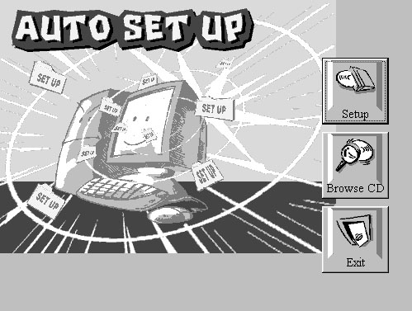
- The setup window will appear as below.
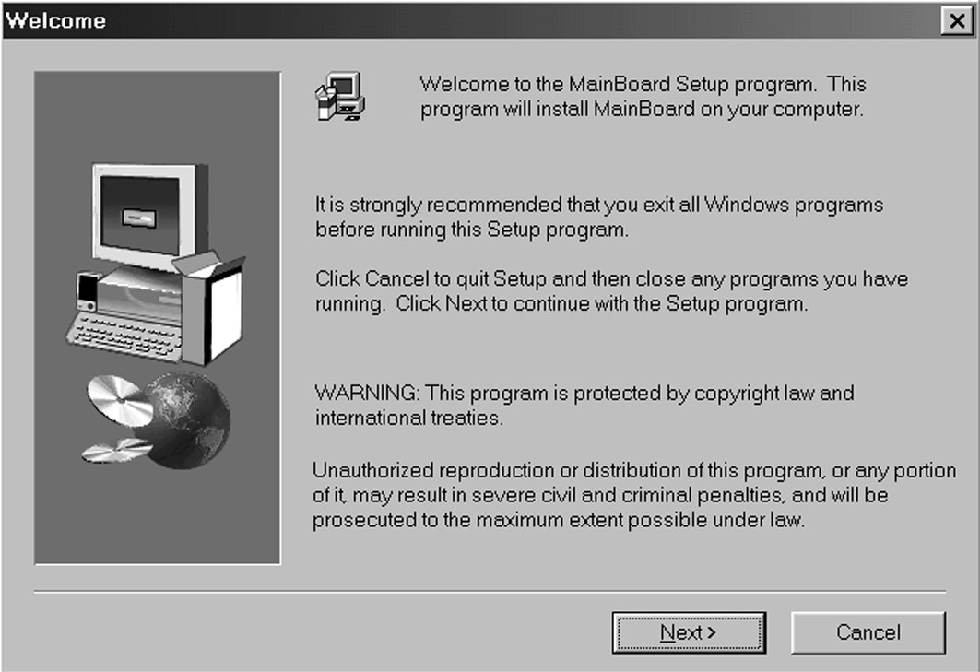
- Click Setup button to continue.
- Click Next button to continue.
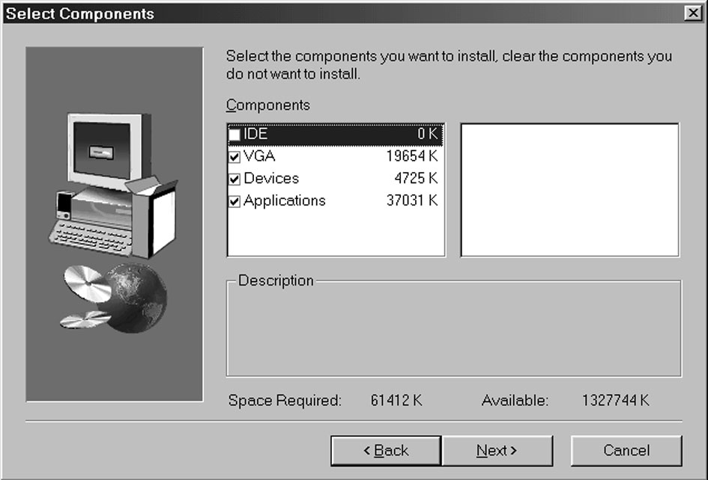
- Select the items that you want to setup by clicking on it (the default options are recommended). Click the Next button to proceed.
- The support software will automatically install.

Once any of the installation procedures start, software is automatically installed in sequence. You will need to follow the onscreen instructions, confirm commands and allow the computer to restart as few times as is needed to complete installing whatever software you selected to install. When the process is finished, all the support software will be installed and working.
There are some utilities that you have to manually install if you need, check to the above section.

Using the PCI Sound Pro Application
- Before you install the Sound drivers, make sure your Operating System has been installed, otherwise the PCI Sound Pro might be detected as “Other device” by the device manager of your OS.
- After the drivers are properly installed, choose the MULTIMEDIA icon in the CONTROL PANEL when you need to use the Software Wave-Table drivers as a MIDI output device. Select the MIDI page and click on “C-media SoftMidi Synthesis (Win98) / Driver (Win95)”, then click “OK” to confirm.
- A Windows application named Audio Rack is provided with the PCI Sound drivers, which gives you control over all the audio functions through a user interface that is as simple to use as a home stereo system. We recommend that you use the System Mixer in the Audio Rack software to control your computer’s audio volume, recording device and the recording gain.
- If the devices that you are using require the MIDI port as the control interface, you need to select the MULTIMEDIA icon in the CONTROL PANEL. Select the MIDI page and click on “CM8738 MPU-401” (Win98) or “CM8738/C3DX PCI Audio External MIDI Port” (Win95), and then click “OK” to confirm.
- For more information, refer to the PCI Sound Pro manual in the CD which ships with this mainboard.

The Four Speakers System
The onboard Sound Pro audio system supports 2 wave channels (front/rear) known as the 4 speaker system. If you are running applications which use the DirectSound® 3D or A3D® audio interface, your system can simulate realistic 3D sound through a 4 speaker setup. Follow the steps below to install a 4-speaker setup.

Speaker Installation
Connect the front two speakers to the Line-out jack on the sound ports extension bracket. Connect the rear two speakers to the Line-in/Rear jack on the sound ports extension bracket. The original Line-in can be moved to Aux.

Speaker Position
Set up your speakers similar to the following figure to get the best audio result.

