Chapter 3

BIOS Setup

Introduction
The BIOS setup utility stores information about your computer such as the date and time, the kind of hardware you have installed, and so on. Your computer uses this information to initialize all the components at boot up time, and make sure that everything runs smoothly.

If the information in the setup utility is incorrect, it may cause your system to malfunction. It can even stop your computer from booting properly. If this happens, you can use the clear CMOS jumper to clear the CMOS memory area that is used to store the setup information, or you can hold down the End key while you reboot your computer, Holding down the End key also clears the setup information.

You can run the setup utility and manually make changes to the setup utility. You might need to do this to configure some of the hardware that you add to the mainboard, such as the CPU, the memory, disk drive, etc.

Running the Setup Utility
Each time your computer starts, before the operating system is booted, a message appears on the screen that prompts “Hit <DEL> if you want to run SETUP”. When you see this message, press the Delete key and the Mainmenu page of the setup utility appears on your monitor.

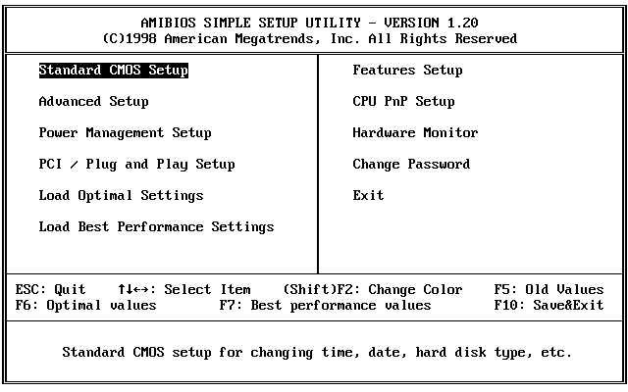

You can use the cursor arrow keys to highlight any of the options on the Mainmenu page. Press Enter to select the highlighted option. To leave the setup utility, press the Escape key. Hold down the Shift key and press F2 to cycle through the optional color schemes of the setup utility.

Some of the options on the Mainmenu page lead to tables of items with installed values. In these pages, use the cursor arrow keys to highlight the items, and then use the PgUp and PgDn keys to cycle through the alternate values for each of the items. Other options on the Mainmenu page lead to dialog boxes which require you to answer Yes or No by hitting the Y or N keys.

If you have already made changes to the setup utility, press F10 to save those changes and exit the utility. Press F5 to reset the changes to the original values. Press F6 to install the setup utility with a set of default values. Press F7 to install the setup utility with a set of best-performance values.

Standard CMOS Setup Page
Use this page to set basic information such as the date and time, the IDE devices, and the diskette drives. If you press the F3 key, the system will automatically detect and configure the hard disks on the IDE channels.

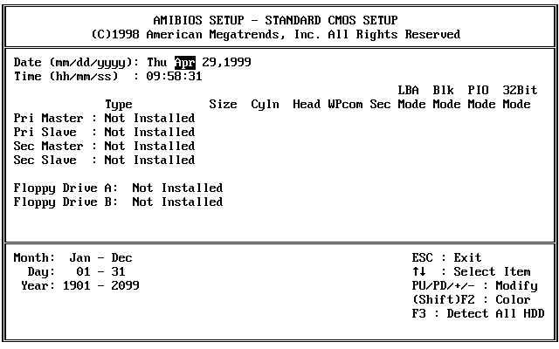

Date & Time | Use these items to install your system with the correct date and time
Pri Master  Pri Slave  Sec Master  Sec Slave | Use these items to configure devices on the primary and secondary IDE channels. To configure a hard disk drive, choose Auto. If the Auto setting fails to find a hard disk drive, set it to User, and then fill in the hard disk characteristics (Size, Cyls, etc.) manually. If you have a CD-ROM drive, select the setting CDROM. If you have an ATAPI device with removable media (e.g. a ZIP drive or an LS-120) select ARMD.
Floppy Drive A  Floppy Drive B | Use these items to set the size and capacity of the floppy diskette drive(s) installed in the system.

Advanced Setup Page
Use this page to set more advanced information about your system. Take some care with this page. Making changes can affect the operation of your computer.

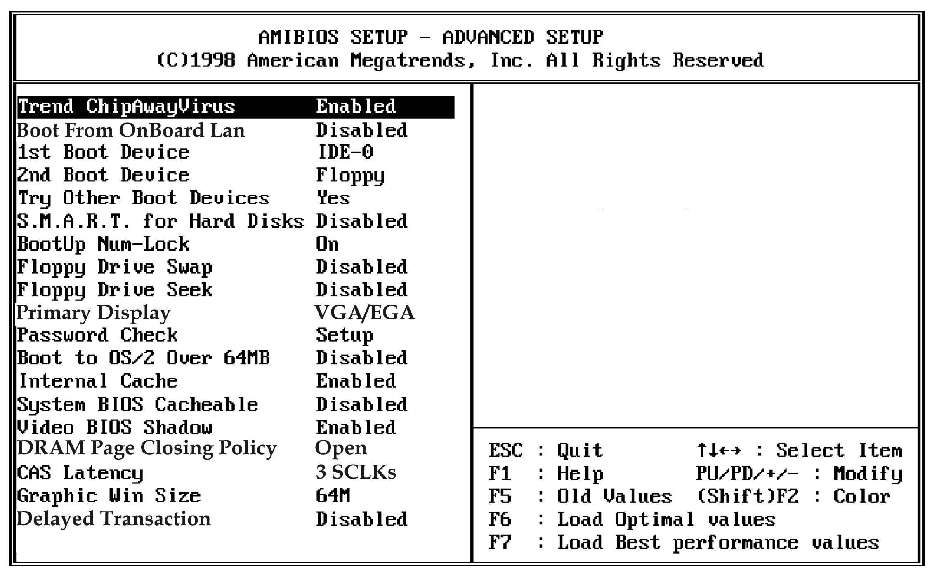
Trend ChipAway Virus | This mainboard has built-in virus protection in the firmware. Use this item to enable or disable the built-in virus protection.
Boot From OnBoard Lan | If you enable this item, the system will boot from onboard LAN.
1st Boot Device  2nd Boot Device | Use these two items to determine the order and priority that your computer follows to load an operating system at start-up time.
Try Other Boot Devices | If you enable this item, the system will also search for other boot devices if it fails to find an operating system from the first two locations.
S.M.A.R.T. for Hard Disks | Enable this item if your hard disk(s) supports SMART (Self-Monitoring, Analysis and Reporting Technology).
BootUp Num-Lock | This items determines if the Num Lock key is active or inactive at system start-up time.
Floppy Drive Swap | If you have two diskette drives installed and you enable this item, drive A becomes drive B and drive B becomes drive A.
Floppy Drive Seek | If you enable this item, your system will check the diskette drives at start up time. Disable this item unless you are using an old 360K diskette drive.
Primary Display | Use this item to determine the display devices for the primary display of your computer.
Password Check | If you have installed a password on your system, use this item to determine if the password is required to enter the setup utility (Setup) or required at start-up time and to enter the setup utility (Always).
Boot to OS/2 Over 64MB | Enable this item if you are booting the OS/2 operating system and you have more than 64MB of memory installed.
Internal Cache | Leave this item enabled since all the processors that can be installed on this board have internal cache memory.
System BIOS Cacheable | If you enable this item, a segment of the system BIOS will be cached to main memory for faster execution.
Video BIOS Shadow | When this item is enabled, 32 kilobytes of the system video BIOS is copied to system memory from where it can execute more rapidly.
DRAM Page Closing Policy | This item determines the operation of the memory Page Closing Policy. We recommend that you leave this item at the default value.
CAS Latency | This item determines the operation of the main memory CAS (column address strobe). We recommend that you leave this item at the default value.
Graphic Window Size | This item determines the operation of the onboard graphics adapter. We recommend that you leave this item at the default value.
Delayed Transaction | If you enable this item, your system will delay the transaction mechanism for AGP master/PCI master. We recommend that you leave this item at the default value.

Power Management Setup Page
This page sets some of the parameters for the system power management operation.

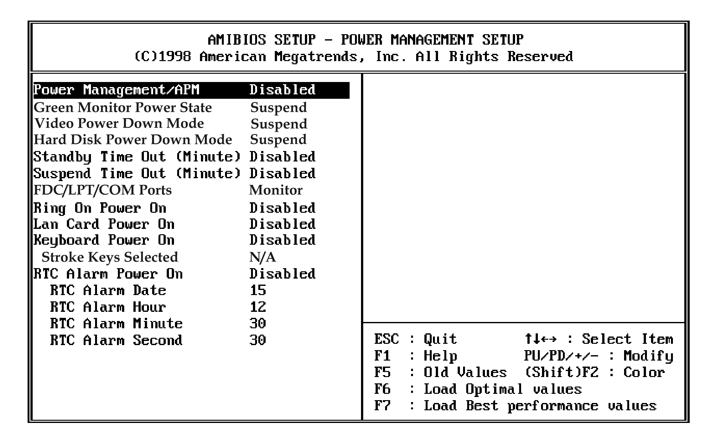
Power Management/APM | Use this item to enable or disable the power management routines. If you enable the power management, you can use the items below to set the power management operation.
Green Monitor Power State | Use this item to determine which power-saving mode is required to power down a green PC-compliant monitor. You can force the monitor to power down in Standby or Suspend modes, or you can disable the powerdown.
Video Power Down Mode | Use this item to determine which power-saving mode is required to power down the graphics sub-system. You can force the graphics to power down in Standby or Suspend modes, or you can disable the powerdown.
Hard Disk Power Down Mode | Use this item to determine which power-saving mode is required to power down the hard disk drive(s). You can force the hard disk to power down in Standby or Suspend modes, or you can disable the powerdown.
Standby Time Out (Minute) | This sets the timeout for standby mode in minutes. If the time selected passes without any system activity, the computer will enter the power-saving standby mode.
Suspend Time Out (Minute) | This sets the timeout for suspend mode in minutes. If the time selected passes without any system activity, the computer will enter the power-saving suspend mode.
FDC/LPT/COM Ports | If you set this item to Monitor, any activity on the floppy disk drive(s)/the parallel port/the serial port can resume the system from a power saving mode.
Ring On Power On | Your system can enter a software power down. If you enable this item, the system can automatically resume if there is an incoming call on the built-in Fax/Modem.
Lan Card Power On | Your system can enter a software power down. If you enable this item, the system can automatically resume if there is traffic on the network adapter.
Keyboard Power On | Your system can enter a software power down. If you enable this item, you can resume the system by pressing hot keys on the keyboard.  You must enable the jumper for Keyboard Power On.
Stroke Keys Selected | If you have enabled the Keyboard Power On, use this item to select the hot keys to power on the system.
RTC Alarm Power On | Your system can enter a software power down. If you enable this item, the system can automatically resume at a fixed time on the system’s RTC (realtime clock). Use the items below to set the date and time of the wake-up alarm.

PCI / Plug and Play Setup Page
This page sets some of the parameters for devices installed on the system PCI bus, and devices that use the system plug and play capability.

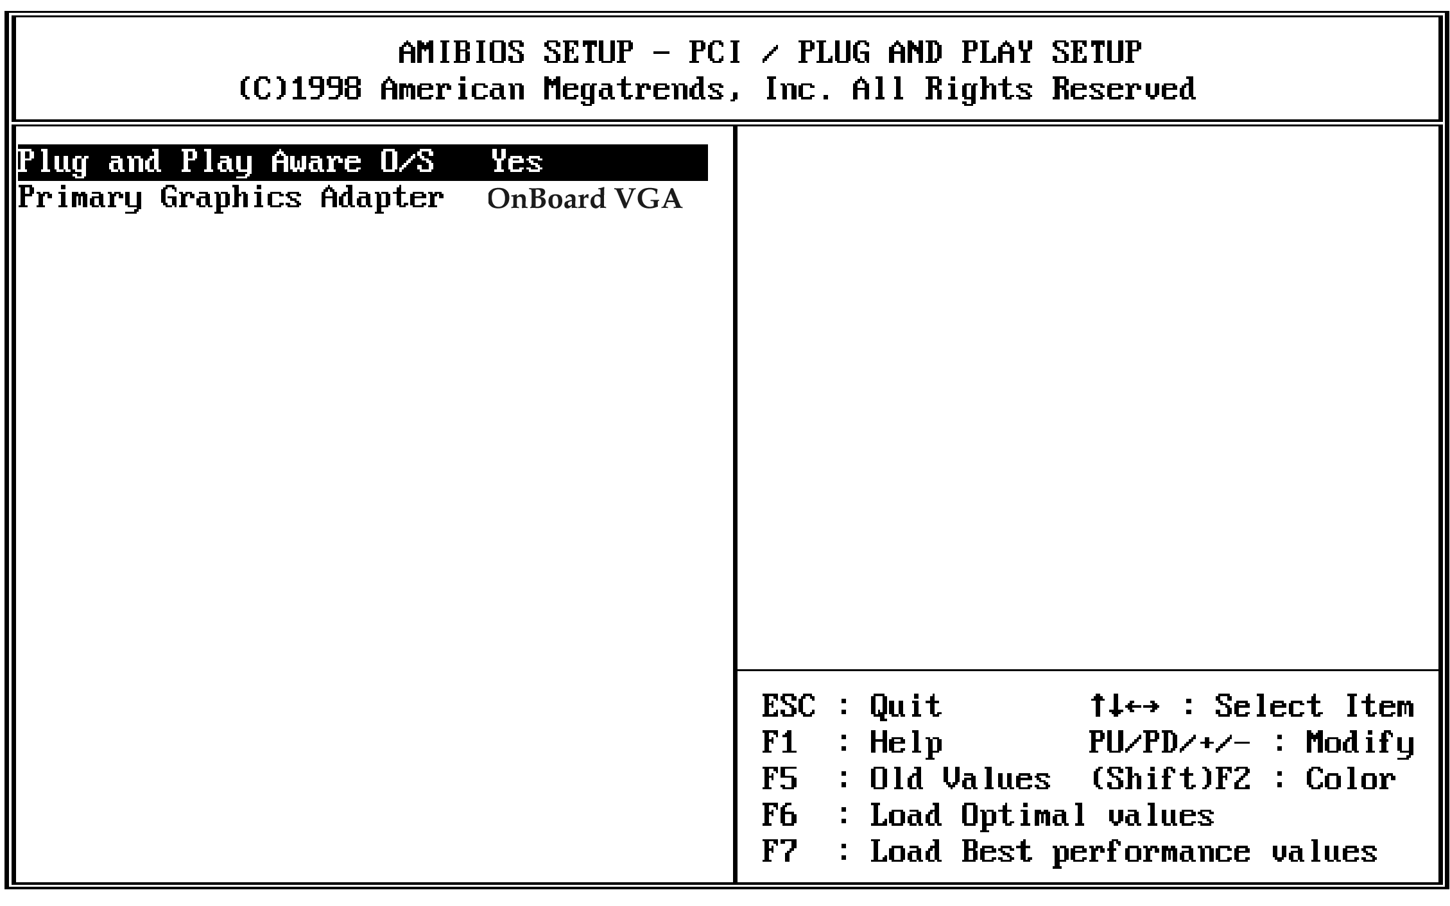
Plug and Play Aware O/S | Enable this item if you are using an O/S that supports Plug and Play such as Windows 95 or 98.
Primary Graphics Adapter | Use this item to define if your primary graphics adapter is installed in a onboard VGA or add-on VGA.

Load Optimal Settings
If you select this item and press Enter a dialog box appears. If you press Y, and then Enter, the setup utility is loaded with a set of optimal default values. The optimal default values are not very demanding and they should allow your system to function with most kinds of hardware and memory chips.

Load Best Performance Settings
If you select this item and press Enter a dialog box appears. If you press Y, and then Enter, the setup utility is loaded with a set of best-performance default values. The optimal default values are quite demanding and your system might not function properly if you are using slower memory chips or other kinds of low-performance components.

Features Setup Page
This page sets some of the parameters for peripheral devices installed on the system.
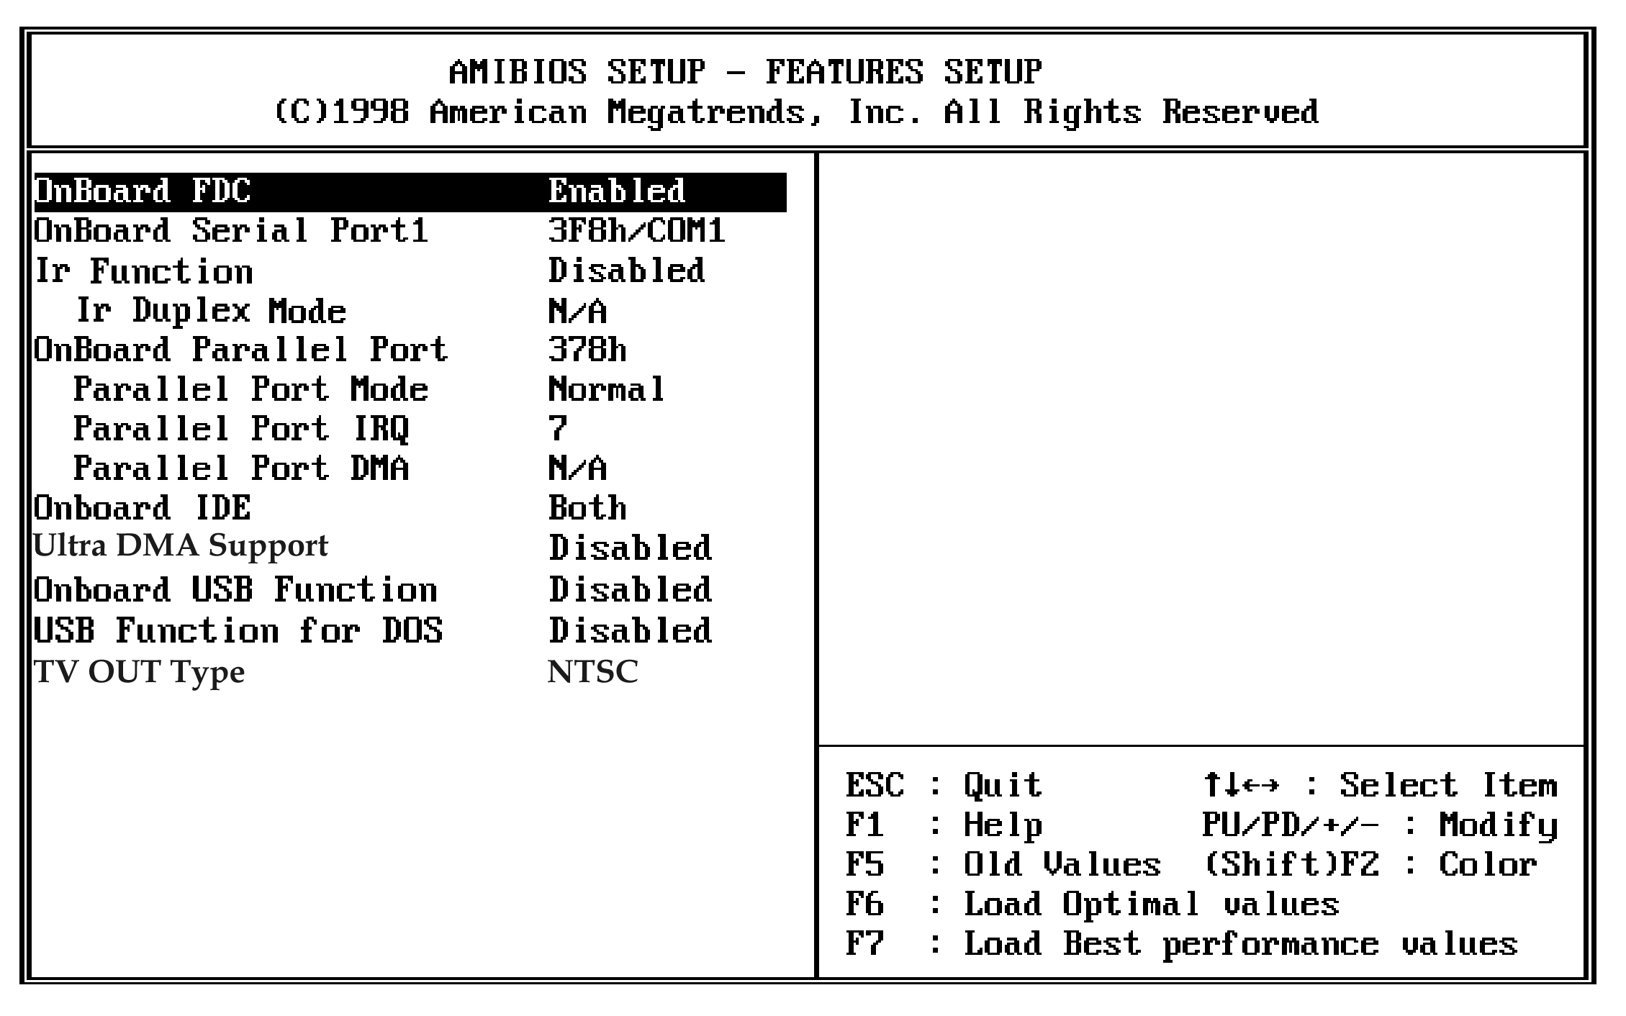
Onboard FDC | Use this item to enable or disable the onboard floppy disk drive interface.
Onboard Serial Port1 | Use this item to enable or disable the onboard serial port COM1, and to assign a port address
IR Function | Use this item to define the protocol for an infrared port if you have installed an optional IR port.
IR Duplex Mode | Use this item to define if the optional infrared port is full-duplex or half-duplex.
Onboard Parallel Port | Use this item to enable or disable the onboard parallel port LPT1, and to assign a port address
Parallel Port Mode | Use this item to determine the parallel port mode. You can select Normal, ECP (Extended Capabilities Port), EPP (Enhanced Parallel Port), or ECP + EPP.
Parallel Port IRQ | Use this item to assign an IRQ to the parallel port.
Parallel Port DMA | Use this item to assign a DMA channel to the parallel port.
Onboard IDE | Use this item to enable or disable either of the two onboard IDE channels, Primary or Secondary.
Ultra DMA Support | Use this item to enable or disable the Ultra DMA function to support the IDE devices.
OnBoard USB Function | Use this item to enable or disable the USB (Universal Bus Ports) that are integrated on this mainboard.
USB Function for DOS | If you have enabled the USB function, use this item to enable or disable USB when you are working in the DOS environment.
TV Out Type | This item is available when TV out kit onboard (optional). Use this item to determine the type of the TV Out . You can select NTSC or PAL.

CPU PnP Setup Page
This page lets you configure the mainboard for the kind of CPU that you have installed.

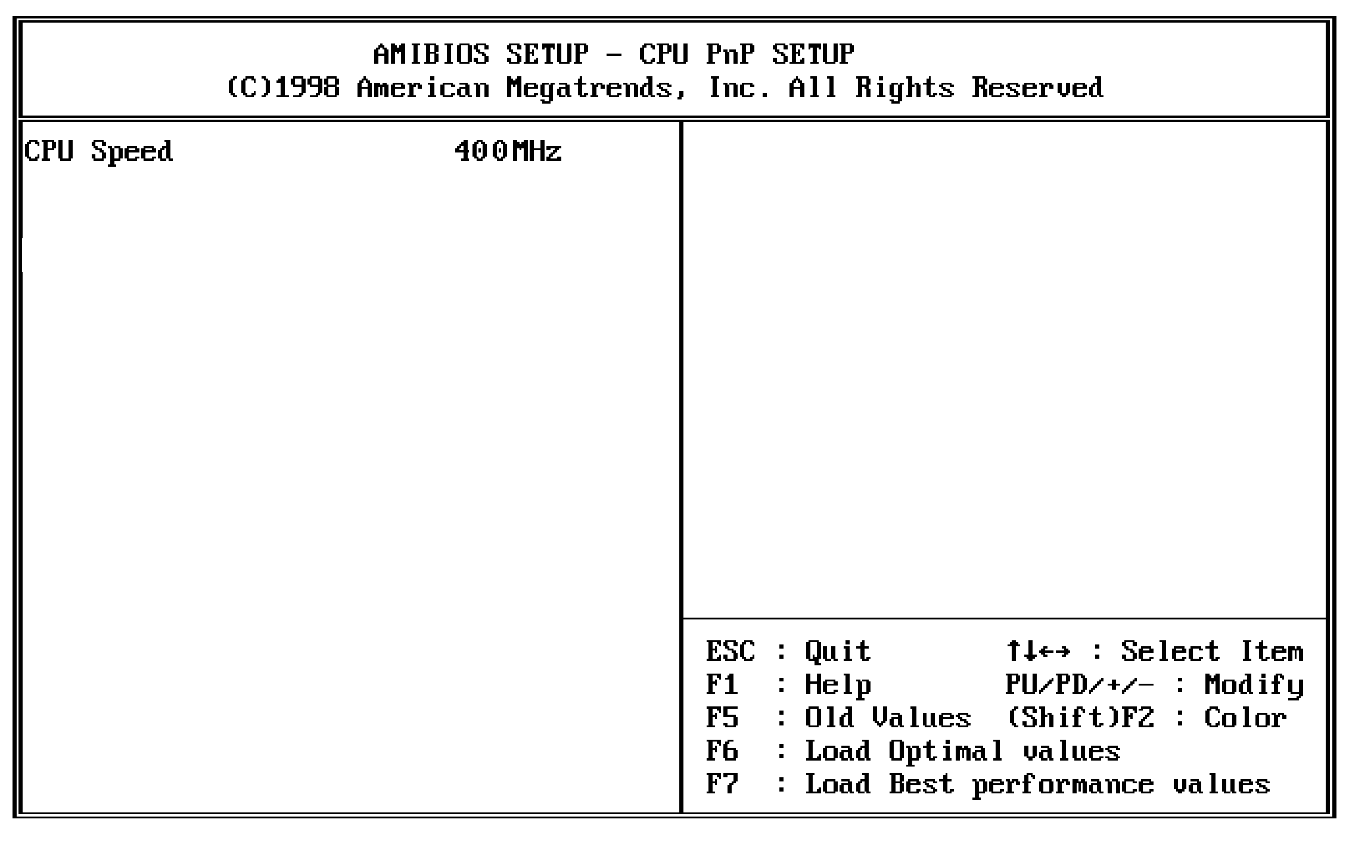
CPU Speed | Use this item to define the clock speed of the processor that you have installed.

Hardware Monitor Page
This page sets some of the parameters for the hardware monitoring function of this mainboard.

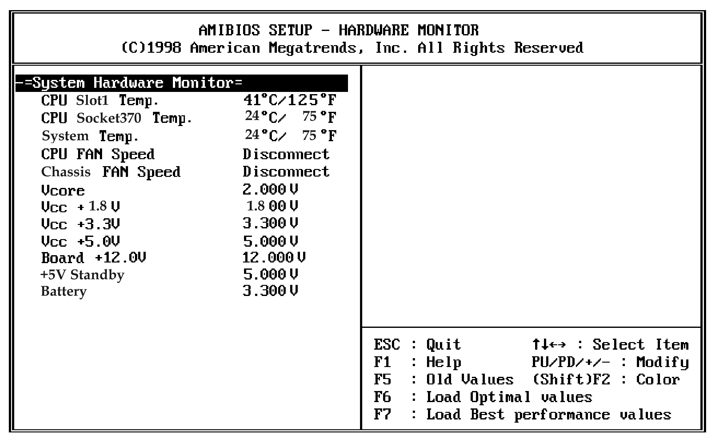
CPU Slot1 / Socket370 & System Temp. | Use these items to monitor the threshold temperature for the CPU and the system chassis.
CPU/Chassis Fan Speed, VCCs & Battery | Use these items to monitor the parameters for the voltages that control the fans and the mainboard.

Change Password
If you highlight this item and press Enter, a dialog box appears which lets you enter a Supervisor password. You can enter no more than six letters or numbers. Press Enter after you have typed in the password. A second dialog box asks you to retype the password for confirmation. Press Enter after you have retyped it correctly. The password is required at boot time, or when the user enters the setup utility.

Change or Remove the Password
Highlight this item and type in the current password. At the next dialog box, type in the new password, or just press Enter to disable password protection.

Exit
Highlight this item and press Enter to save the changes that you have made in the setup utility and exit the setup program. When the Save and Exit dialog box appears, press Y to save and exit, or press N to exit without saving.

