Chapter 2

Mainboard Installation

To install this mainboard into your system, follow the procedures in this chapter:

- Identify the mainboard components
- Install the correct processor
- Install one or more memory modules
- Verify that any jumpers or switches are at the correct setting
- Install the mainboard in the system chassis
- Install any extension cables to the mainboard headers
- Install any other devices and make the appropriate connections to the mainboard headers.

Note: 1. Before installing the mainboard, you must ensure that the Clear CMOS jumper JP9 is set to the Normal setting. See this chapter for information locating JP9 and changing the jumper setting.
2. While installing the mainboard into AT case with ATX power, please make sure the AC power cord is unplugged before the full system is installed completely. Otherwise, it may destroy stuffs unpredictably, due to the power-on trigger event of power management.

Mainboard Components
Use the diagram below to identify the major components on your mainboard.
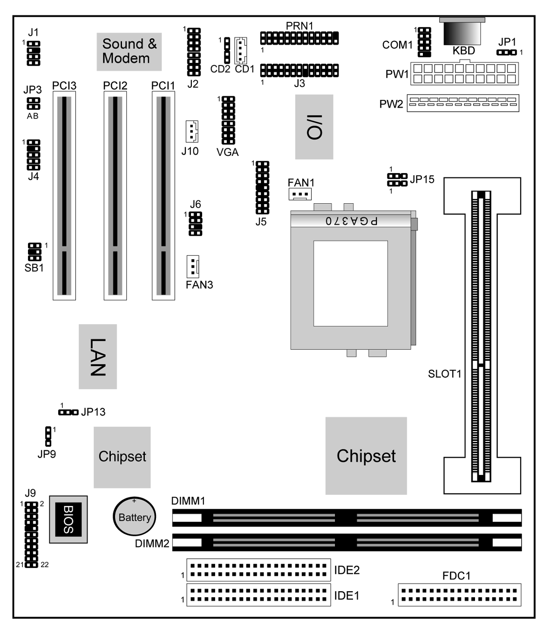

Note: Any jumpers on your mainboard that do not appear in this illustration are for testing only.

Install the Processor
This mainboard has a Slot-1 which can be installed with any Slot-1 processor cartridge including the Pentium-II, the Pentium-III and the SEPP Celeron. It also has a Socket-370 which can be installed with the PPGA Celeron/FCPGA Pentium-III processor.
To ensure reliability, make sure that your processor is fitted with a heatsink/cooling fan assembly.
You can install a Slot-1 processor or a Socket-370 processor. You cannot install a Socket-370 and a Slot-1 processor cartridge together.
Take care that you do not try to install a Socket-7 processor into the Socket-370. A Socket-7 processor such as the Pentium-MMX, or the AMD K5/K6 does not fit in the socket-370.
The following list notes the processors that are currently supported by this mainboard. New processors may be a released after this manual is printed.
Pentium III: Slot-1, 450~800 MHz, FSB: 100MHz
Pentium II: Slot-1, 350~450 MHz, FSB: 100MHz;
233~333 MHz, FSB: 66MHz
SEPP Celeron: Slot-1, 266~433 MHz, FSB: 66MHz
FCPGA Pentium III: Socket-370, 500~800 MHz, FSB: 100MHz
PPGA Celeron: Socket-370, 300~600 MHz, FSB: 66MHz

Installing a Slot-1 Processor Cartridge
- Locate Slot-1, JP15 and FAN1 on the mainboard.
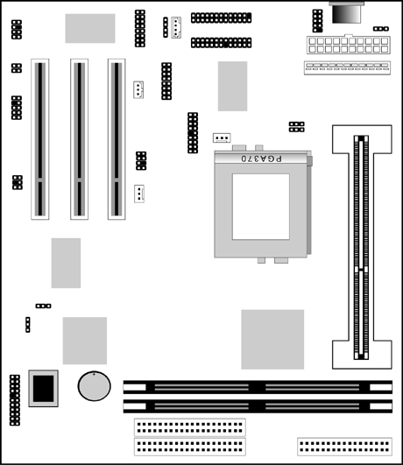
JP15
1
1

FAN1

Slot-1 with pre-installed cartridge holder. The upright arms are folded down for shipping.

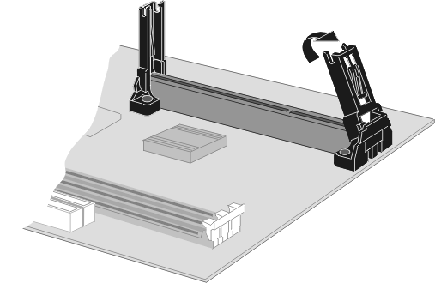
- The Slot-1 is installed with a cartridge holder. The upright struts of the cartridge holder are folded down for shipping. Pull the struts upwards so that they are in the upright position.
- Insert the processor cartridge into the cartridge holder. Follow the instructions given with your processor cartridge. The edge connector on the cartridge has a notch so that it only fits into the Slot-1 in the correct way.
- Locate the cooling fan power supply FAN1. Connect the cable from the processor cartridge cooling fan to FAN1.
- Locate the jumper JP15. Use the two rows of three pins jumper to select you have installed a non-FCPGA Pentium III processor as right.
1
Selects a non-FCPGA Pentium III processor
JP15
1

- On this mainboard, you can configure the processor by entering the correct settings in the BIOS setup utility.

Installing a Socket-370 Processor
The processor installs into the ZIF (Zero Insertion Force) Socket-370 on the mainboard.
- Locate the Socket-370, JP15 and FAN1. Pull the locking lever out from the socket and swing it to the upright position.
JP15
1
1
FAN1

Socket-370

Pin-1 Corner

- On the processor, identify the pin-1 corner by noting that it has a slight bevel.
- On the Socket-370, identify the pin-1 corner. The pin-1 corner is on the same side as the locking lever, closest to the top of the lever when it is in the locked position.
- Match the pin-1 corners and insert the processor into the socket. No force is required and the processor should drop into place freely.
- Swing the locking lever down and hook it under the catch on the side of the socket. This locks the processor in the socket.
- If the processor is installed with a cooling fan assembly, connect the cable from the fan to the CPU fan power connector FAN1.
- Locate the jumper JP15. Use the two rows of three pins jumper to select if you have installed a FCPGA Pentium III processor as below.
1
Selects a FCPGA Pentium III processor
JP15
1
1
Selects a PPGA Celeron processor
JP15
1

Install Memory
The mainboard has two DIMM slots which can be installed with memory modules. You must install at least one memory module in order to use the mainboard.
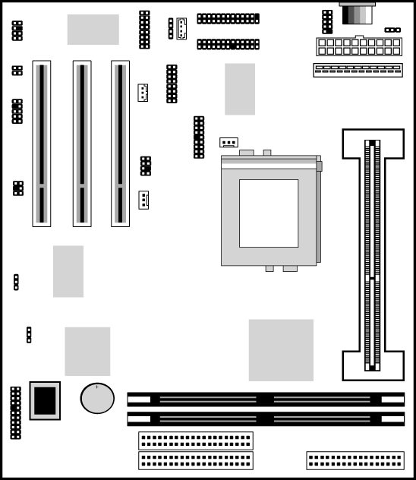

DIMM1

DIMM2

For this mainboard, you must use 168-pin, 3.3V memory modules installed with SDRAM memory chips. You must use memory that operates on a 100 MHz memory bus (PC-100 memory). You can install any size of memory module from 16 MB up to 256 MB, so the maximum memory size is 2 x 256 MB = 512 MB.

The edge connectors on the memory modules have cut outs, which coincide with struts in the DIMM slots, so the memory modules can only be installed in the correct way.

On the DIMM slot, pull the locking latches at either end of the slots outwards. Position the memory module correctly and insert it into the DIMM slot. Press the module down into the slot so that the locking latches lever inwards and lock the module in place.

Set the Jumpers
Jumpers are sets of pins that can be connected together with jumper caps. The jumper caps change the way the mainboard operates by changing the electronic circuits on the mainboard. If a jumper cap connects two pins, we say the pins are SHORT. If a jumper cap is removed from two pins, the pins are OPEN.
JP3
JP1
A B
1
JP13
1

JP15
1
1
1
JP9

Jumper JP1: Keyboard Power On Selector
If you are using an ATX power supply unit, you can use hot keys on your keyboard as a power on/off switch for the system. Use this jumper to turn this feature on or off.
Note: Make sure that the system can provide 1A on +5VSB (+5V Standby) signal before using the Keyboard Power On function.
Function | Jumper Setting
Enable Keyboard Power On | Short Pins 1-2
Disable Keyboard Power On | Short Pins 2-3

Jumper JP9: Clear CMOS Memory
Use this jumper to clear the contents of the CMOS memory. You may need to clear the CMOS memory if the settings in the setup utility are incorrect and prevent your mainboard from operating. To clear the CMOS memory, disconnect all the power cables from the mainboard and then move the jumper cap into the CLEAR setting for a few seconds.
Function | Jumper Setting
Normal Operation | Short Pins 1-2
Clear CMOS Memory | Short Pins 2-3

Jumper JP3(A, B): Onboard Fax/Modem & Audio Enable/Disable
This jumper has two rows of two pins. The left row (JP3-A) is used to enable or disable the onboard Fax/Modem. The right row (JP3-B) is used to enable or disable the onboard audio system.

Function | Jumper Setting
Enable Onboard Modem | Open JP3-A Pins
Disable Onboard Modem | Short JP3-A Pins

Function | Jumper Setting
Enable Audio | Open JP3-B Pins
Disable Audio/Modem | Short JP3-B Pins

Note: If you use the right row of pins to disable the onboard audio system, the Fax/Modem is disabled, even if you have set the left row of pins to the enable Fax/Modem setting.

Jumper JP13: Enable/Disable Onboard LAN
Use this 3-pin jumper to enable or disable the onboard network adapter.

Function | Jumper Setting
Enable Onboard LAN | Short Pins 1-2
Disable Onboard LAN | Short Pins 2-3

Jumper JP15: Select FCPGA Pentium III Processor
Use the two rows 3-pin jumper to prepare the mainboard to use either a FCPGA (Socket-370) Pentium III processor or not.

Function | Jumper Setting
FCPGA Pentium III CPU | Short all Pins 1-2
Non FCPGA Pentium III CPU | Short all Pins 2-3

Install the Mainboard
Install the mainboard into the system chassis. This mainboard is baby AT-sized and the I/O ports are provided on extension brackets. In addition the mainboard can operate using an AT power supply unit or an ATX power supply unit. This means that you have a wide choice of cases that can be used by this mainboard.

Install the mainboard into the unit case. Follow the instructions provided by the case manufacturer using the screws and mounting points provided in the chassis.

FAN3

ATX-PW1
1

AT-PW2

J9

Connect the power cable from the power supply unit to the power connector on the mainboard. If you are using an AT power unit, connect it to the AT power connector PW2. If you are using an ATX power unit connect it to the ATX power connector PW1.

If the case that you are using has a chassis cooling fan, connect the power cable from the fan to the onboard chassis cooling fan power supply FAN3.

Connect the case switches and indicator LEDs to the bank of switch and LED connectors J9. See the illustration below for a guide to the pin functions of the J9 case connector.
21 22
Power LED
Pins 2-4-6
Speaker
Pins 1-3-5-7
Keylock
Pins 8-10
HDD LED Pins 15-16
1 2
Reset Switch Pins 17-18

Green LED Pins 19-20
Power Switch Pins 21-22

Install the Extension Brackets
The extension brackets are used to transmit features on the mainboard to external connectors that can be fixed to the system chassis. Follow the steps below to install the extension brackets.

Note: All the ribbon cables used on the extension brackets carry a red stripe on the pin-1 side of the cable.

Audio Ports and Game/MIDI Port Extension Bracket
This bracket provides three audio jacks for stereo line in, stereo line out and microphone. In addition it has a 15-pin D-connector which can be used by either a joystick or a MIDI device.
If you are using a four channel speaker system, channel one and two are output through the Stereo Line-out, and the rear speaker channels three and four are output through Stereo Line-in.

J3-Audio Header
1

Audio Ports & Game/MIDI Extension Bracket
Stereo Line-in /Rear speaker channels 3-4
Microphone
Stereo Line-out /Speaker channels 1-2
Game/MIDI

- On the mainboard, locate the J3 audio header for this bracket.
- Plug the cable from the bracket into the J3 audio header.
- In the system chassis, remove a blanking plate from one of the expansion slots and install the extension bracket in the slot. Use the screw that held the blanking plate in place to secure the extension bracket.

Serial/Parallel Ports Extension Bracket
This bracket has one serial port - COM1 (9-pins) and one parallel port – LPT1 (25pins). On this mainboard, the second serial port is reserved for the Fax/Modem card so you can only connect one of the serial ports to the manboard header COM1.

1
COM1 Header
Serial Port
COM1
Parallel Port
LPT1
1
PRN1- Parallel Port Header

Serial/Parallel Ports
Extension Bracket

- On the mainboard, locate the headers COM1 and PRN1 for this bracket.
- Plug the serial cable into COM1 and the parallel cable into PRN1.
- In the system chassis, remove a blanking plate from one of the expansion slots and install the extension bracket in the slot. Use the screw that held the blanking plate in place to secure the extension bracket.

LAN Adapter Extension Bracket
This bracket supports an RJ45 network connector and connects to the built in J4 LAN header on the mainboard.
1

J4 LAN Header

LAN Extension Bracket

- On the mainboard, locate the J4 LAN header for this bracket.
- Plug the cable from the bracket into the LAN header.
- In the system chassis, remove a blanking plate from one of the expansion slots and install the extension bracket in the slot. Use the screw that held the blanking plate in place to secure the extension bracket.

Fax/Modem DAA Module
The Fax/Modem DAA module plugs directly into the mainboard adjacent to an expansion slot in the system chassis. When you remove the blanking plate from the system chassis, you can access the LINE and TEL RJ11 connectors on the metal edge of the Fax/Modem DAA module.
J2-MODEM Header

2 MCLK
4 FRA-SY
6 SCLK
8 RIN-WAK
10 GPIO
12 SDO
14 SDI
16 RST
GND 1
GND 3
GND 5
AUX 3V 7
HOOK 9
RIN 11
AUX 5V 13
MUTE 15

- Locate the J2 Modem header on the mainboard.
- Plug the Fax/Modem DAA module into the J2 Modem header.
- Remove the blanking plate adjacent to the Fax/Modem DAA module.
Modem DAA Module
Line & Tel
RJ11 Sockets

J2 Modem Header

VGA Extension Bracket
The VGA extension bracket has a 15-pin connector for an external monitor cable.
VGA Header
1

VGA Extension Bracket

- On the mainboard, locate the VGA header for this bracket.
- Plug the cable from the bracket into the VGA header.
- In the system chassis, remove a blanking plate from one of the expansion slots and install the extension bracket in the slot. Use the screw that held the blanking plate in place to secure the extension bracket.

Optional Extension Brackets
For this mainboard, you can also obtain an ATX Form Card and an AV/S-Video output extension bracket. Install these brackets by following the steps below.

ATX Form Card
This ATX Form Card provides a mini-DIN port for infrared, one mini-DIN port for a PS/2 mouse. In addition it has two USB (Universal Serial Bus) ports.
J5-ATX Header
1

Infrared Port

PS/2 Mouse
Port
USB Ports
ATX Form Card

- On the mainboard, locate the J5 ATX header for this bracket.
- Plug the cable from the bracket into the J5 ATX header.
- In the system chassis, remove a blanking plate from one of the expansion slots and install the extension bracket in the slot. Use the screw that held the blanking plate in place to secure the extension bracket.

AV/S-Video Output Extension Bracket
This bracket has an AV jack and a S-Video jack for the television out.

1
J6 TV-Out Header

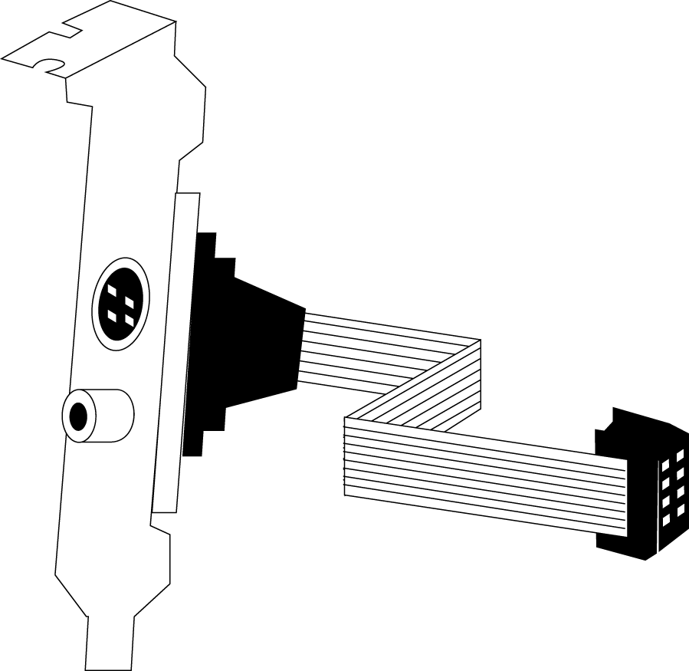

AV/S-Video Output Extension Bracket

- On the mainboard, locate the J6 TV-Out header for this bracket.
- Plug the cable from the bracket into the J6 TV-Out header.
- In the system chassis, remove a blanking plate from one of the expansion slots and install the extension bracket in the slot. Use the screw that held the blanking plate in place to secure the extension bracket.

Install Other Devices
Install and connect any other devices in the system following the steps below.
IDE2
1
IDE1
1

FDC1
1

Floppy Disk Drive
The mainboard ships with a floppy disk drive cable that can support one or two drives. Drives can be 3.5” or 5.25” wide, with capacities of 360K, 720K, 1.2MB, 1.44MB, or 2.88MB.

Install your drives and supply power from the system power unit. Use the cable provided to connect the drives to the floppy disk drive header FDC1.

IDE Devices
IDE devices include hard disk drives, high-density diskette drives, and CD-ROM/DVD drives.

The mainboard ships with an IDE cable that can support one or two IDE devices. If you connect two devices to a single cable, you must configure one of the drives as Master and one of the drives as Slave. The documentation of the IDE device will tell you how to configure for Master or Slave.

Install the device(s) and supply power from the system power unit. Use the cable provided to connect the device(s) to the Primary IDE channel connector IDE1 on the mainboard.

If you want to install more IDE devices, you can purchase a second IDE cable and connect one or two devices to the Secondary IDE channel connector IDE2 on the mainboard. If you have two devices on the cable, one must be Master and one must be Slave.

Internal Sound Connections
If you have installed a CD-ROM drive or a DVD drive, you can connect the sound output of the drive to the built-in sound system.

On the mainboard, locate the two 4-pin connectors for CD1 and CD2. There are two kinds of connector because different brands of CD-ROM drive have different kinds of cable connectors on their audio output cable. Connect the cable to the appropriate connector.

1

CD2
CD1

Expansion Slots
This mainboard has three 32-bit PCI expansion slots. The PCI1 slot is shared with the onboard VGA, the PCI2 slot is shared with the onboard LAN, and the PCI3 slot is shared with the onboard audio system. It means that you can use either one of shared both but you cannot use the both at the same time.
PCI3 PCI2 PCI1

J10-LAN Wake Up Header

1

SB1-SB-Link Header

Follow the steps below to install a PCI expansion card.
- Locate the PCI slot on the mainboard.
- Remove the blanking plate from the appropriate expansion slot on the system chassis.
- Install the edge connector of the expansion card into the slot and press it quite firmly down so that it is seated correctly.
- Secure the bracket of the card into the expansion slot in the system chassis using the screw that held the blanking plate in place.

LAN Wake Up
If you are using an ATX power supply and you have installed a LAN adapter expansion card, connect the card to the LAN Wake Up header J10. This allows incoming traffic to resume the system from a software power down.

SB-Link
If you have disabled the built-in audio system and installed a PCI Sound Blaster audio card, you can connect the card to the SB-Link header on the mainboard. The SB-Link circuit solves some problems that can occur when you try to play some older computer games which run in the DOS real-mode environment.

