TriGem Micro-ATX Motherboard (COGNAC)
Hardware Document

July, 27 1999

Revision 1.0
Prepared by JS Kim
Approved by SE Hong

Document Revision History
Released date | Revision | Description
June, 10 1999 | Rev. 0.9 | First released version for this document.  This document describes the major specification of the Cognac motherboard and the functional feature to be extended by the customer.  The motherboard revision number is EVT3(PR1)
July, 27 1999 | Rev. 1.0 | 1. PCB Rev Up (A→C)  2. It is modified in the connector option of M/B

Marketing Information
Address 45-2 Yoidodong, Youngdeungpoku, Seoul, Korea
Telephone 82-2-3774-4251 (International Business Team)
Fax 82-2-786-9478
Email jhpark@trigem.co.kr (Jin Hyun Park)

Technical Support
Address 1055 Shingil-Dong, Ansan, Kyunggi-Do, Korea
Telephone 82-345-491-9528 (Ext. 608)
Fax 82-345-593-6721
Email sehong@trigem.co.kr (Seung Eung Hong)
ycpark@trigem.co.kr (Young chul Park)
jskim2@trigem.co.kr (Jin Soo Kim)

User’s Notice
No part of this product, including the schematics and BIOS may be reproduced, transmitted, transcribed, stored in a retrieval system, or translated into any language in any form by any means without the express written permission of TriGem Computer Inc. except the document kept by the purchaser for backup purposes.

© Copyright 1999 TriGem Computer Inc. All rights reserved

Contents of Table

I. Introduction

1. Generation Description ------------------------------------------------------------ 4
2. Function Block Diagram ------------------------------------------------------------ 6

II. System Overview

1. Major Units ----------------------------------------------------------------------------- 7
2. Upgrade ability ------------------------------------------------------------------------- 8
2-1. Processor -------------------------------------------------------------------------- 8
2-2. Main chipset Configuration ---------------------------------------------------- 9
2-3. Memory ----------------------------------------------------------------------------- 8
2-4. BIOS --------------------------------------------------------------------------------- 9
2-5. Expansion Slot -------------------------------------------------------------------- 9
2-6. Advanced Configuration and Power Interface (ACPI) ------------------- 10
2-7. Manufacturing Options ---------------------------------------------------------- 10

III. Jumper & Connector Description

1. Motherboard Jumper Setting ------------------------------------------------------ 11
1-1. Selection for Processor CPU Clock ------------------------------------------ 11
1-2. Other functionality --------------------------------------------------------------- 11
1-3. PCI graphics device function ------------------------------------------------- 12
1-4. OEM/ODM selector -------------------------------------------------------------- 12
2. Motherboard Connector Description --------------------------------------------- 14
2-1.Motherboard Internal Connector --------------------------------------------- 14
2-2.Motherboard External I/O Port ------------------------------------------------ 16

I. Introduction

The COGNAC Micro ATX motherboard offers a time to market consumer and corporate desktop solution featuring the Intel Celeron PPGA processor with 66/100MHz front side bus and the Whitney chipsets in a Micro ATX low profile motherboards. In addition, the integrated onchip graphics controller supports 4MB of SDRAM purpose of Display cache memory.
The Cognac motherboard was designed to be highly minimized system cost. In this effort a smaller form factor, Micro-ATX, gives the greater space economy and more affordable systems. Integrating onchip graphics controller and SDRAM, as well as onchip AC’97 audio solution with AC97 Codec onto the motherboard eliminates the need for more expensive graphic and audio add-in cards. The end result is a system platform with a primary component level of integration with translates into affordable solution for entry level users.

1. General description

❑ Motherboard
• Small PCB size in the Micro ATX form factor (ATX V1.2 form factor)
• 238mm * 238mm * 1.6t (4 Layers)

❑ Processor
• Intel Socket-370 (370pin PPGA Socket)
- Intel Celeron 400/433/466/500MHz processor @66MHZ Host clock
- Intel TBD @100MHZ Host clock

❑ Main Chipset
• Graphics and Memory Controller Hub (GMCH) : Intel FW82810-DC100 / FW82810
• I/O Controller Hub (ICH) : Intel FW82801AA / FW82801AB
• AC 97’ Controller : Intel FW82801AA/AB included
• Audio Codec : Cirrus CS4299-JQ
• Super I/O : ITE IT8702F-A
• DC-DC Converter : HARRIS HIP6021CB
• Clock : ICS 9250BF-10 (66/100MHz host clock,
100Mhz SDRAM Clock support)

❑ Memory Configuration
• System Memory
- Two banks of 3.3V SDRAM (168pin unbuffered DIMM) with max 256MB
- SDRAM operation in 100MHz front side bus
• Display Cache Memory
- Two 1M*16 3.3V SDRAM (4MB)
- SDRAM operation in 100MHz
• Flash Memory
- Intel N82802AB, 4Mb PLCC Type
- FirmWare Hub(FWH) Interface for platform operation
- Address/Address Multiplexed Interface for programming during manufacturing

❑ I/O Feature
• Integrated standard I/O functions in the rear side
- One multi-mode parallel port
- One FIFO serial ports and optional port by header type
- PS/2 styles keyboard and mouse port
- Two USB port
- Three audio jack for Speaker output ,Line input and MIC input
- One Joystick port
• I/O Controller (IT8702F-A)
- Low Pin Count (LPC) interface with Host controller(ICH)
- FDC, Parallel, Serial, keyboard/Mouse supported
- Joystick port and MPU-401 compatible MIDI interface

❑ Audio Subsystem
• Intel 82801AA/AB AC’97 Audio/Modem controller
• Independent channels for PCM in and PCM out, Microphone in
• Left and Right audio channels
• 16 bit sample resolution
• multiple sample rates
• AC’97 2.1 compliant AC-link interface

- GMCH Subsystem

• Host/Memory(DRAM) Controller features
- 66/100Mhz System Bus Frequency
- 100Mhz system memory bus frequency
- Refresh mechanism: CBR only supported
- Support for Asymmetrical DRAM addressing only
- Support for Asymmetrical DRAM addressing only
- Support for 64-bit data interface
- Suspend to RAM support
• Graphics Controller features
- 3D Hyper Pipelined Architecture ( PDP, PPI)
- full 2D H/W Acceleration
- Motion Video Acceleration
- H/W motion Compensation Assistance for S/W MPEG2 Decode
- Software DVD at 30fps
• 3D Graphics features
- Flat & Gouraud Shading
- Mip Maps with Bilinear and Anisotropic Filtering
- Fogging Atmospheric Effects
- Z Buffering
- 3D Pipe 2D Clipping
- Backface Culling
- Per Pixel Perspective Correction Texture Mapping
- Texture Compositing
- Texture Color Keying/Croma Keying
• Display features
- Integrated 24-bit 230Mhz RAMDAC
- Gamma Corrected Video
- DDC2B Compliant
• Graphics memory controller features
- Intel D.V.M Technology (Dynamic Video Memory)
• Display Cache Interface (FW82810-DC100 only)

- ICH Subsystem

• PCI Bus Interface
• Integrated IDE controller
• USB
• AC’97 Link for Audio and Modem
• Interrupt Controller
• Low Pin Count Interface
• SM Bus
• Firmware Hub Interface

- GMCH,ICH vs GMCH0,ICH0 Configuration Difference

GMCH, ICH | GMCH0, ICH0
Display Cache (4MB) Support | No Display Cache (4MB) Support
Up to Ultra 66 ATA Spec. Support | Up to Ultra 33 ATA Spec. Support
6 PCI Slots Support | 4 PCI Slots Support
Alert on LAN Support | N/A
Note : Pavilion 6530/6535 uses the GMCH0, ICH0

2. Function Block Diagram

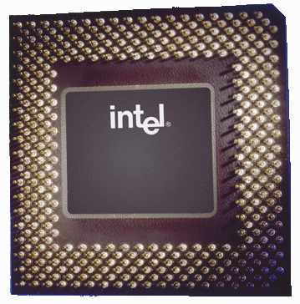
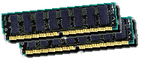
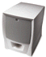
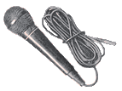
Intel Celeron
PGA 370
DIMM Modules
MD
MA
HA
HD
Speaker
MIC
Line in
2M
2M
SDRAM

DCMD
DCMA

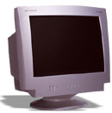
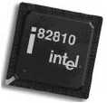
RGB
Video
DCMD
DCMA

GMCH / GMCH0

Hub
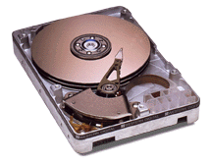
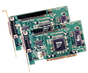
HDD
PCI Slot
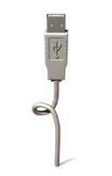
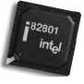
HD Data
HA Address
Keyboard
Mouse
Serial
Parallel
USB
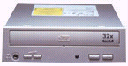
CDROM

ICH / ICH0

Code
c
CS4299
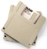

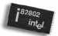
FWH

I/O
IT8702F

Joystick
Midi

II. System Overview

1. Major Units

FW82810
Display cache
(Not used)
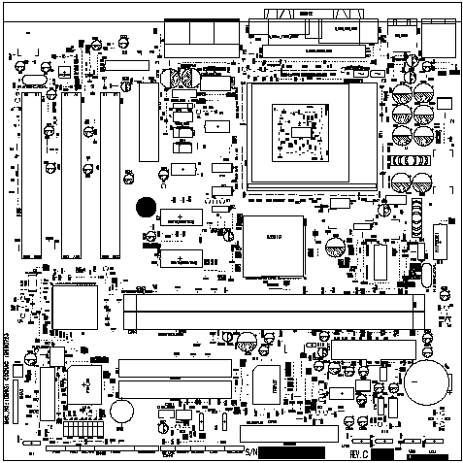
AC97 codec
Audio Amp
PCI Slots
AMR Slots
FW82801AB
82802AB(ROM)
CDR CONNECTOR
FDD CONNECTOR
IT8702
POWER CONN
RTC Battery
DIMM
HIP6021CB
9250BF-10
CPU
Serial driver 2
Serial driver 1
HDD CONNECTOR

2. Upgradeability

2-1. Processor

COGNAC motherboard provides the 370pin PGA370 socket that is not backward compatible with ZIF socket-7 processors The Processor’s VID pins automatically program the voltage regulator on the motherboard to the required processor voltage. The motherboard supports processors that run internally at 300/333/366/400 /433/466/500MHz.

❑ Supported Intel Celeron Processors (PPGA Socket Type)
• Host Clock 66MHz : Celeron 400MHz
: Celeron 433MHz
: Celeron 466MHz
: Celeron 500MHz
: tbd
• Host Clock 100MHz : tbd

❑ Supported Cyrix Goby Processors (PPGA Socket Type)
• Host Clock 66MHz : tbd

2-2. Main Chipset Config

Cognac Motherboard has two main chipset configurations.

❑ 810DC100 Configuration
• GMCH + ICH : FW82810DC100 + FW82801AA

❑ 810L Configuration
• GMCH0 + ICH0 : FW82810 + FW82801AB

→ It’s applied to Cognac, Cognac+

2-3. Memory

The motherboard has two, dual inline memory module (DIMM), minimum 16MB to maximum 256MB memory size. The BIOS can automatically detect the memory type, size, and speed through SMBUS interface between the core chipset and DIMM module.

The motherboard supports the following memory features

• 3.3V and unbuffered168-pin DIMM

Voltage detection
3.3V Version 5V Version

Unbuffered detection
Unbuffered Buffered

• 100MHz unbuffered SDRAM (PC100)
• Non-ECC memory only
• Single or double-sided DIMM with the following types (per each side of each DIMM)

DIMM size | Non-ECC memory | DIMM size | Non-ECC memory
8MB | 4*(1M * 16 bit) | 64MB | 8*(8M * 8 bit)
16MB | 8*(2M * 8 bit) | 64MB | 4*(8M * 16 bit)
32MB | 4*(4M * 16 bit) | 128MB | 8*(16M * 8 bit)
32MB | 2*(4M * 32 bit)

2-4 BIOS

The motherboard uses a TriGem-Phoenix BIOS, which is stored in flash memory and can be upgraded using a disk-based program. A new version of the BIOS can be upgraded from a diskette using the Flash Memory Update utility.

❑ Flash memory organization

Address (Hex) | Size | Functional description
FFFF0000 - FFFFFFFF | 64KB | Boot block
FFF82000 - FFFEFFFF | 440KB | Main BIOS block
FFF80000 - FFF81FFF | 8KB | ESCD block

❑ On-board device management

The BIOS can manage the devices on the motherboard over the CMOS setup menu.
Device | Description | CMOS setup menu | Default value
PS/2 Mouse | Intel 82801AB (ICH) | Enabled / Disabled / Auto Detect | Auto Detect
Legacy USB | Intel 82801AB (ICH) | Enabled/ Disabled | Disabled
AC’97 Audio | ICH with CS4299 Codec | Enabled / Disabled | Enabledd
On board FDC | Super I/O (ITE8702) | Enabled / Disabled | Enabled
On board serial A | Super I/O (ITE8702) | Enabled / Disabled | Enabled
On board serial B | Super I/O (ITE8702) | Enabled / Disabled | Disabled
On board parallel | Super I/O (ITE8702) | Enabled / Disabled | Enabled
Midi port | Super I/O (ITE8702) | Enabled / Disabled / Auto | Auto
Game port | Super I/O (ITE8702) | Enabled / Disabled / Auto | Auto

2-5. Expansion Slot

The motherboard support PCI and GMCH function. PCI functions are extended to the additional slot with 3 PCI, and GMCH function is designed in the motherboard with Integrated System/Graphics controller.

❑ PCI configuration space map

Bus number | Device number | Function number | Device
00 | 30 | 00 | Intel 82801AB(ICH0) PCI Bridge
00 | 31 | 00 | Intel 82801AB(ICH0) LPC Bridge
00 | 31 | 01 | Intel 82801AB(ICH0) Bus master IDE
00 | 31 | 02 | Intel 82801AB(ICH0) USB Host Controller
00 | 31 | 03 | Intel 82801AB(ICH0) SM Bus Controller
00 | 31 | 04 | Reserved
00 | 31 | 05 | Intel 82801AB(ICH0) AC’97 Audio Controller
00 | 31 | 06 | Intel 82801AB(ICH0) AC’97 Modem Controller
00 | 31 | 07 | Reserved
00 | 00 | 00 | Intel 82810(GMCH0) System/Graphics  Controller
00 | 01 | 00 | Intel 82810(GMCH0) Internal Graphics Device
01 | 0E | 00 | PCI slot1
01 | 0D | 00 | PCI slot2
01 | 0C | 00 | PCI slot3

❑ PCI interrupts & Master Number Routing Maps

Intel 82801AB (ICH0) PCI bridge has four programmable interrupt request input signals. Any PCI interrupt source connects to one of these interrupt signals and It’s assigned to the free proper interrupt number by PnP BIOS.

ICH INT  signals | First  PCI slot | Second  PCI slot | Third  PCI slot | ICH0  USB device | ICH0  SM Bus
PIRQA | INTA | INTB | INTC
PIRQB | INTB | INTC | INTD
PIRQC | INTC | INTD | INTA
PIRQD | INTD | INTA | INTB | INTC | INTB
Master | REQ0 | REQ1 | REQ2
IDSEL | AD30 | AD29 | AD27

ICH INT  signals | ICH0  AC’97 Audio | ICH0  AC’97 Modem | GMCH  Internal Graphics Device
PIRQA
PIRQB
PIRQC
PIRQD | INTB | INTB | INTA
Master
IDSEL

2-6. Advanced Configuration and Power Interface (ACPI)

The motherboard and system BIOS supports the ACPI that requires an ACPI-aware operating system such as Windows-NT 5.0 or Windows 98 SE. ACPI feature include
• Plug and play and APM functionality normally contained in the BIOS
• Power management control of individual devices : add-in cards, hard disk drives, USB devices, and Video
• A soft-off feature that enables operating system to power off the computer
• Support for multiple wakeup events
• Indication LED for normal mode (Green), standby mode (Blinking Green) function is dependent on the
LED logic.

❑ Wakeup devices and events

Wakeup device | Wakeup events and functionality
Power switch | Wakeup from Power-off status and S1Status
LAN | Wakeup from S1 status
Modem | Wakeup from S1 status

2-7. Manufacturing Options

The motherboard has several manufacturing options according to OEM/ODM requirement. Make sure that these options can be applied in the assembly stage, and it’s impossible to upgrade or change in the customer field.

Option items | Selectable functionality | Feature changes
Joystick port | Front side / Rear side | Use additional board or not
USB port | Front side / Rear side | Use additional board or not
Super I/O | IT8712 / IT8702 | Include H/W monitoring or not
Graphics controller | FW82810 / FW82810-DC100 | Display Cache or not
Display Cache memory | None / 4MB | Display Cache or not

III. Jumper & Connector Description

1. Motherboard Jumper Setting

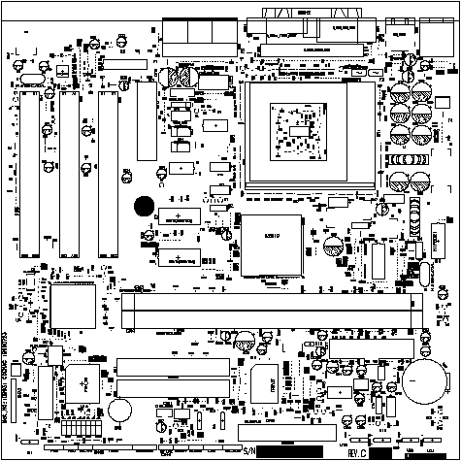

J1 – J8

1-1. Selection for Processor CPU Clock
 Intel Celeron PPGA Processor is auto set the core to bus frequency ratio.

1-2. System functionality (J1,2,3,4,5,8 is TG Option)

DIP Switch | Function | 1-2(Default) | 2-3
J6 | Clear CMOS | Disable | Enable
J7 | Audio Function(AMR)  Primary Down | Enable | Disable
* Note : Pavilion 6530 uses J6,7
Pavilion 6535 uses J6

1-3. PCI graphics device function

No jumper does set the functionality of the GMCH graphics controller
PCI Graphics device operates automatically if PCI Graphics card is inserted .

1-4. OEM/ODM selector (TG Option)

These jumpers (J1, J2 & J3) will be optional parts for the OEM/ODM logo message selector of Trigem.

BIOS  Factory  Setting  (J1,2,3 | J2(2-3), J3(2-3),J4(2-3) | Reserved | J2(2-3), J3(2-3),J4(1-2) | Reserved
BIOS  Factory  Setting  (J1,2,3 | J2(2-3), J3(1-2), J4(2-3) | Reserved | J2(2-3), J3(1-2), J4(1-2) | Reserved
BIOS  Factory  Setting  (J1,2,3 | J2(1-2), J3(2-3), J4(2-3) | Reserved | J2(1-2), J3(2-3), J4(1-2) | Reserved
BIOS  Factory  Setting  (J1,2,3 | J2(1-2), J3(1-2), J4(2-3) | Reserved | J2(1-2), J3(1-2), J4(1-2) | Reserved

* Factory Default Setting - bold type text

2. I/O Header Connector Description

2-1. Motherboard Internal Connector

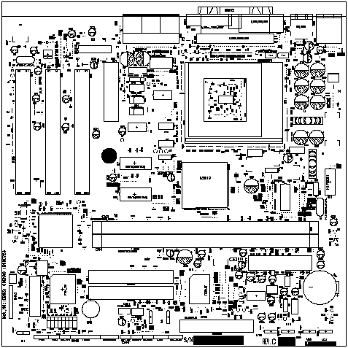
MODEM SOUND(CN46)
MODEM SOUND(CN6)
VIDEO SOUND(CN45)
CD SOUND(CN43)
CD SOUND(CN44)

JOY_USB (CN72)

HPD INDICATOR(CN73)

TG INDICATOR(CN48)
FAN CONNECTOR
(CN53)
FAN CONNECTOR
(CN54)
LAN CONNECTOR
(CN50)
RING CONNECTOR(CN51)

❑ CPU FAN connector (CN53)

Pin number  1 2 3  CN53 | Signal description
1 | GND
2 | FAN power
3 | Tachometer (speed)

❑ System Chassis FAN connector (CN54)

Pin number  1 2 3 | Signal description
1 | GND
2 | FAN control
3 | Tachometer (Speed)(GND)

❑ PC/PCI connector (CN23) (TG Option)
Pin  2 4 6  1 3 5 | Signal description | Pin | Signal description
1 | /PCGNTA | 4 | /PCREQA
2 | GND | 5 | N.C
3 | Key | 6 | SER_IRQ

❑ Joystick & USB connector (CN72) (TG Option)
Pin | Signal description | Pin | Signal description
1 | VCC | 9 | VCC
2  3 1 8 7 6 5 4 3 2 1  4 2 16 15 14 13 12 11 10 9 | GD(4) | 10 | GD(6)
3 | GD(0) | 11 | GD(2)
4 | GND | 12 | MIDI OUT
5 | GND | 13 | GD(3)
6 | GD(1) | 14 | GD(7)
7 | GD(5) | 15 | MIDI IN
8 | VCC | 16 | Key
1 | GND | 3 | Positive DATA
2 | Negative DATA | 4 | VCC

❑ Video Sound (CN45) (TG Option)
Pin  1 2 3 4 | Signal description | Pin | Signal description
1 | Left Sound | 3 | GND
2 | GND | 4 | Right Sound

❑ Modem Sound (CN46, CN6) (TG Option)
Pin  1 2 3 4 5  CN46 | Signal description | Pin | Signal description
1 | MIC | 4 | GND
2 | GND | 5 | MONO IN
3 | MONO OUT

Pin  1 2 3 4  CN6 | Signal description | Pin | Signal description
1 | MONO IN | 3 | GND
2 | GND | 4 | MIC

❑ CD Sound (CN43(TG Option), CN44)

Pin  1 2 3 4  ATAPI CD (CN43) | Signal description | Pin | Signal description
1 | Left Sound | 3 | GND
2 | GND | 4 | Right Sound

Pin  1 2 3 4  Mitsumi CD (CN44) | Signal description | Pin | Signal description
1 | GND | 3 | GND
2 | Left Sound | 4 | Right Sound

❑ LAN Wakeup (CN50) (TG Option)
Pin  1 2 3 4 | Signal description | Pin | Signal description
1 | +5VSB | 3 | LANWK
2 | GND

❑ Modem Wakeup (CN51) (TG Option)
Pin  1 2 3 4 | Signal description | Pin | Signal description
1 | Modem Ring | 3 | +5VSB
2 | GND

❑ HPD Indicator Header (CN73)
PWR HDD DC/SW
8
9

Pin | Signal description
1 | NC
2 | GND
3 | LED POWER
4 | NC
5 | LED POWER
6 | HDD access signal
7 | GND
8 | Power-ON switch signal

❑ Aux. Indicator Header (CN49) (TG Option)

Pin | Signal description | Pin | Signal description
1 | Key lock Signal to Super I/O | 2 | GND
3 | Key | 4 | Reset signal
5 | GND | 6 | Key
7 | Sleep Function signal | 8 | GND

2-2. Motherboard External I/O Port

Parallel port Serial port
Monitor USB Keyboard/Mouse

Joystick port

Line-in Speaker
Mic

Mic in

Trademarks

Microsoft, Windows and Windows NT are registered trademarks of Microsoft Corporation.

